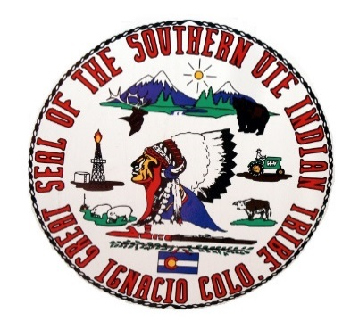
Southern Ute Indian Tribe
Southern Ute Cultural & Preservation Department
P.O. Box 737, Mail Stop #73, Ignacio CO 81137
Phone: 970-563-0100 Fax: 970-563-1098
May 23, 2018

TJ Broom
Mountain Sports-Recreation Special Uses Program Lead
900 Grand Avenue
Glenwood Springs, CO 81601

Dear Ms. Broom,

I have reviewed your Consultation Request under section 106 of the National Historic Preservation Act regarding the EA for Aspen Skiing Company Lift project and offer the following response as indicated by the box that is checked.

NO INTEREST: I have determined that there is not a likelihood of eligible properties of religious and cultural significant to the Southern Ute Indian Tribe.
NO EFFECT: I have determined that there are no properties of religious and cultural significance to the Southern Ute Indian Tribe that are listed on the National Register within the area of potential effect or that the proposed project will have no effect on any such properties that may be present.
NO ADVERSE EFFECT: I have identified properties of cultural and religious significance within the area of effect that I believe are eligible for listing in the National Register, for which there would be no adverse effect as a result of the proposed project.
ADVERSE EFFECT: I have identified properties of cultural and religious significance within the area of potential effect (APE) that are eligible for listing in the National Register. I believe the proposed project would cause an adverse effect on these properties.
REQUEST FOR ADDITIONAL INFORMATION: The Southern Ute Indian Tribe requests additional information on the planned site for its impact on properties of religious and cultural importance to the Tribe as follows: We request to be a consulting party due to areas that are of cultural and religious significance within the vicinity of the project.
Note:

Sincerely,

Ms. Cassandra Atencio
NAGPRA Coordinator
Southern Ute Cultural Department
Southern Ute Indian Tribe

