Below are Pictures of Units the USFS calls Clearcuts with Reserve Trees or Islands. The USFS tries to Trick the Public into Believing Clearcuts with Reserves and Islands are Visually Appealing and don’t Resemble Clearcuts. Decide for yourself. This is what you will do to Hungry Ridge.
Are you Proud?

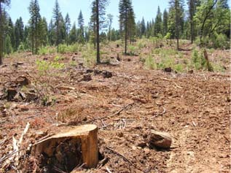

A professional landscape architect would refuse to be involved with a project having such clear visual destruction. Where would you pitch your tent?

