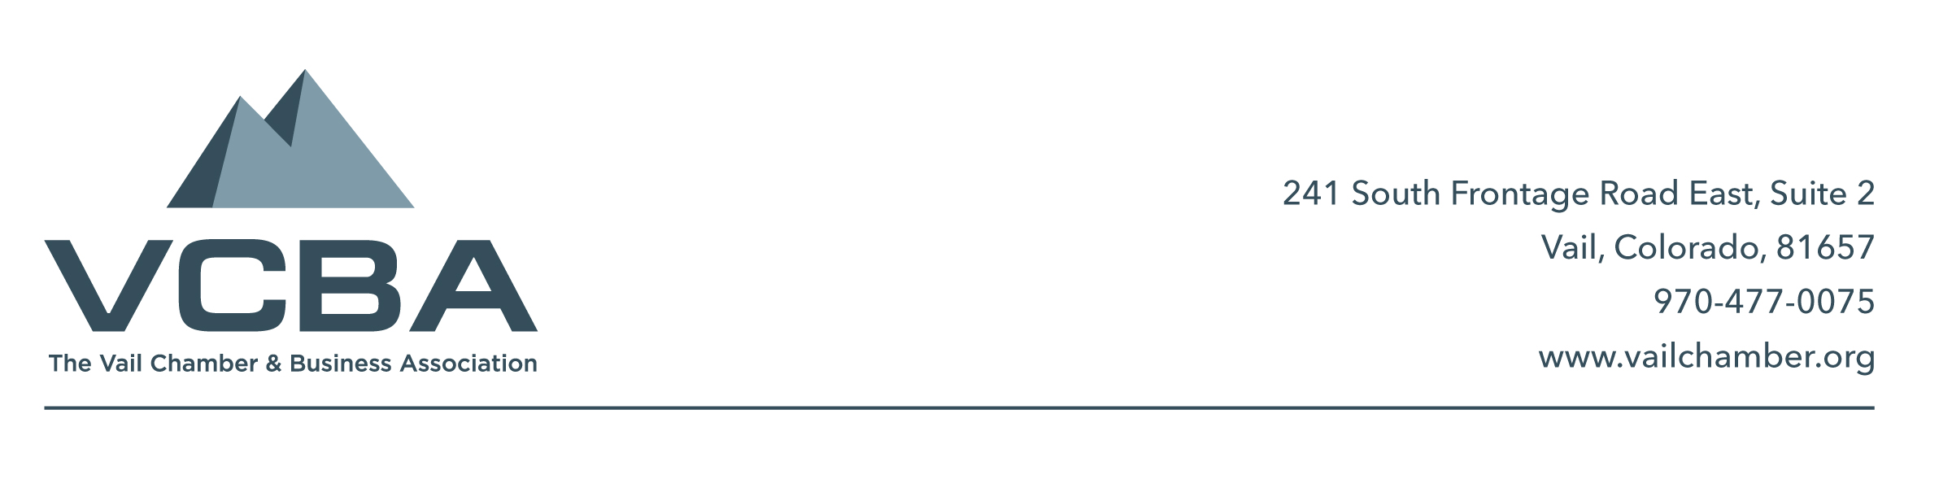

May 24, 2018

White River National Forest
Mountain Sports Permit Department
PO Box 190
Minturn, CO 81645

Dear Mr. Scott Fitzwilliams:

I am writing you today to voice support for the Beaver Creek Resort – McCoy Park Terrain proposal. Although some may view Beaver Creek Resort as competition to our services here in Vail, I see the opposite in that they are complimentary resorts and the quality of service and activities that we both provide will ensure our dual success. This being said, the McCoy Park proposal will be a welcome addition to resort offerings and provide a fun and safe family – friendly experience for our winter guests.

From the proposal I have seen it is clear that Beaver Creek Resort has been mindful in its planning of how to implement these improvements when it comes to wildlife and national forest impact. The added terrain and lifts would improve the guest experience by adding more beginner and intermediate terrain which services our family-oriented guests. Having more room to spread out, enjoy and learn sport will create loyal guests who will be brand ambassadors and choose to return year after year. More happy visitors to our county will help maintain our local businesses from East Vail to Gypsum. The proposed enhancements to Beaver Creek Resort are well thought out and worthwhile improvements.

Thank you for your time and consideration on this proposal. I know that there are many factors to consider and I hope that the positive economic impact these improvements would have on our local economy will be noted as well in your decisions.

Respectfully,

Alison Wadey
Executive Director
Vail Chamber and Business Association

