Dear Humboldt-Toiyabe Forest and Mr. Winfrey,

Here are initial comments of WildLands Defense on the Humboldt-Toiyabe Forest’s limited Scoping information for the “Integrated” Invasive Plant Treatment EIS, in response to the FS’s Scoping letter.
The project is:

https://www.fs.usda.gov/project/?project=53031

We are very concerned that the Forest ignores passive restoration in its Scoping information, and instead relies on the same old, failed aggressive chemical methods.

We are very concerned the Forest has not adequately mapped and inventoried exotic cheatgrass, bromes and other aggressive flammable annual grasses and mustards. Is their occurrence shown on the Scoping weed occurrence map? The acres of weeds are much too low in the Map in the scoping document - approx. 28,000. What is the basis for this mapping? What are the 58 species?

The FS proposes large-scale mechanical biological (targeted grazing is NOT biological control- it just worsens weed problems and animal species habitat harm), fire, other so-called “restoration”, etc. In reality, this is a Spray or Treat and walk Away approach, ingoring taking action to control the causal factors of invasive species “problems”. It is an Un-integrated approach.

The Forest must conduct a series of detailed Risk Assessments. One Risk Assessment must be done to identify areas susceptible to/at risk for cheat and medusahead expansion under the FS’s grazing, treatment and other disturbances that are causing widespread weed expansion. Then, the risk of weed expansion under continued grazing, and/or high treatments levels, and/or energy developed or mining must be factored in. See Attached WLD Comments on BLM processes which are directly relevant to this nearly identical HT FS cookie cutter document. Federal land agencies are using the same old failed actions - instead of focusing on integrated passive restoration and removal of disturbance as the primary method of invasive species control - this it the only way to save areas not yet suffering infestations. The Forest must consider lands at significant to not be Capable or Suitable for continued livestock grazing - due to serious conflicts with sage-grouse, pygmy rabbit, migratory songbirds, native raptors, etc.as well as potential impacts on “sustainability” of “forage”.

Just look at the White Pine Range on the Scoping Weed Map, where the Forest has been cutting, burning, masticating and other wise destroying pinyon-juniper aggressively. It is a morass of weeds. It clearly is time for a new strategy, not the old failed strategy of the Scoping info.

We are alarmed at how the FS loosely applies Adaptive Management - it appears as an excuse for never following a plan with sideboards and triggers for specific action - such as removal of grazing to prevent further weed expansion in areas suffering rapid wee growth- as just one example.

This is a cookie cutter approach - nearly identical to the BLM’s recent Fuelbreak and Restoration PEIS Scoping and other recent proposals in their “invasive” species actions, and BLM’s rubber-stamp of dangerous new chemical herbicides.

The FS must also conduct its own new Risk Assessments for the witches brew of chemicals it lists in the Scoping info. This includes risks of the active ingredients, adjuvants, and other chemicals used potentially in combination, etc. The existing BLM Risk Assessments on which the FS typically piggybacks, are old, out-dated, based on very limited “studies” often does by the chemical industry in areas far removed form the arid, windy rugged, lands of the project area.

Under no circumstances should any aerial herbicide use be allowed.

Plateau and its ilk must be banned. It kills native vegetation - resulting in scorched earth gray dead zones.

The Scoping info shows that the FS would seriously endanger the health of immuno-sensitive or other chemicals sensitive people attempting to visit FS lands.

Both terrestrial and aquatic species habitats and populations are threatened by the aggressive treatment actions and lack of passive restoration found in the proposal scoping materials.

The FS must fully consider the immense battery of treatment and other disturbances taking place across BLM Lands as well as part of a hard look cumulative effects analysis.

Any drift or killing of non-targeted vegetation has greater risk now due to climate change stress - combined with harmful grazing and other FS actions that reduce the ability of lands to recover.

Please fully consider all of the issues and concerns raised in the Attached BLM project comments and integrated alternative and mitigation actions as part of our comments the FS Invasive Species EIS process - as they are directly relevant to the FS actions proposed, as well as the high levels of FS grazing and treatments another activities that are causing the weed crisis in the first place.

We object to the FS not having a direct e-mal to submit comments to. Federal agencies are increasingly losing public comments, and the public deserves to have their own e-mail as a record.

Please let us know you have received these comments, and the associated documents re: BLM processes that are directly relevant to this HT process.

Sincerely,

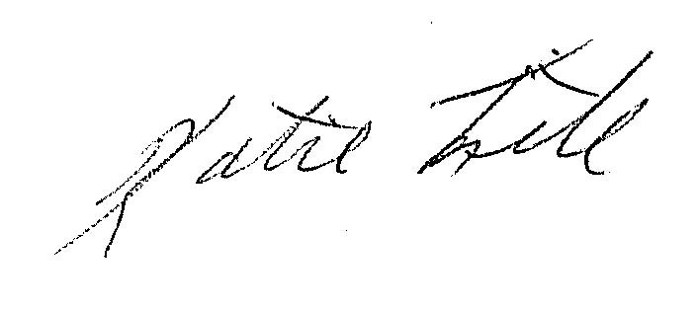

Katie Fite
WildLands Defense
PO Box 125
Boise, ID 83701
208-871-5738

