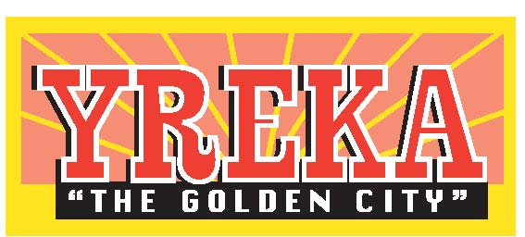 | City of Yreka  701 Fourth Street • Yreka, CA 96097  (530) 841-2386 • FAX (530) 842-4836 | 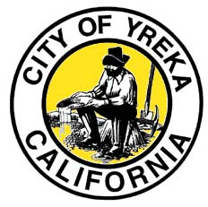

November 6, 2017

Patricia A. Grantham
Forest Supervisor
Forest Service
Klamath National Forest
1711 South Main Street
Yreka California 96097
RE: Craggy Vegetation Management

Dear Ms. Grantham:

The City of Yreka would like to express its support of the Craggy Project. Fire safety is critical in the urban -wildland interface and long term planning and implementation of best practices in the forests is a crucial way of preventing the most serious of fires that could threaten out community and surrounding areas.

The Fire Chief and I have reviewed the various options for implementation of the Craggy Vegetation Management Project. We believe that Alternative 3 provides more protection for our community than the other two alternatives. In addition, we believe that coordination with other projects and funding sources active between the Craggy project limits and the City is crucial. We would suggest that a regular coordination process be set up to coordinate projects in adjacent areas to help provide the most protection for

We have some concerns about the maintenance of the various treatments suggested. We would suggest continued maintenance of key fire breaks close to populated areas continue to be a priority even after the initial work is done.

We are encouraged by and supportive of this project. Feel free to contact us if you require additional information.

Sincerely,

Steven W. Baker
City Manager

cc: Jerry Lemos, Yreka City Fire Chief

