Laura Neale
423 Sheep Creek Lane
Fairfield, VA 24435
Tel 540-261-1909
September 5, 2017

Associate Deputy Chief Glen Casamassa
U.S. Forest Service
Washington, DC 20426

RE: Atlantic Coast Pipeline Decision Objection

Dear Deputy Chief Casamassa,

I am writing to express my objection to the Forest Service draft Record of Decision to allow—by amending the forest management plan-use and occupancy by the proposed Atlantic Coast pipeline (ACP).

I have submitted comments to George Washington National Forest Supervisors Tom Speaks and Joby Timm, and to the Federal Energy Regulatory Commission, opposing construction of the ACP across National Forest lands.

The construction of an industrial corridor as proposed for the 42 inch pipeline would permanently degrade the national forest lands in numerous ways. Some impacts can be measured in a quantitative way. Of grave concern to me are the numerous impacts that cannot be measured because there are no precedents for such a project in forestlands of this nature---i.e. geology and slope and water features----and because there are impacts of a qualitative nature that are not deemed relevant---i.e. both long term biological impacts and the impacts on our human species from addition of another corridor upon unfragmented national forest lands.

Environmentally degrading consequences of construction of a 42 inch buried gas pipeline and corridor include the following:

1. Creation of a corridor for the proposed pipeline would require clear-cutting a path through the National Forest. This is permanent removal of forest, and life forms associated with forest including healthy soils and soil biota. Compacted soils are a permanently lost resource, also.

2. Loss of habitat is probably the most significant factor contributing to decreasing numbers of forest dwelling wildlife populations. The removal of a swath of forest to create a corridor not only removes forest habitat, but also is particularly damaging as it fragments the forest. The fragmentation of this clear cut would compromise the forest interior by reducing its size. Blocks of forest interior are the most threatened forest habitat and are at constant threat of being nibbled away. Another fragmentation result which may be exponentially damaging to many forest interior wildlife species is the creation of edge habitat which brings in many wildlife species like Cowbirds, Blue Jays, raccoons, and opossums who outcompete and/or parasitize those requiring forest interior. The total loss of forest habitat would be far greater than the actual cleared land. Bird species of concern include many neotropical migrants who rely on our forests as way stations and as breeding habitat. Breeding species of concern include Cerulean Warblers and Wood Thrushes. Other wildlife species impacted would include amphibians, reptiles, mammals, insects, and, micro biota.

3. Creation of such a corridor would provide both easy access and ideal growing conditions for invasive exotic plants. There is no foolproof method to control this threat to our native flora and fauna. Exotics are completely out of control in many places, and we should be particularly protective of areas that have not been infested.

The mountains of western Virginia comprise some of the very last and finest unfragmented Appalachians, and construction of this pipeline would have permanent and irredeemable negative consequences.

The construction of the proposed ACP pipeline would cause major damage to every National Forest landscape through which it would pass, and impact biological, hydrological, and cultural systems far beyond the route itself. The negative and permanent consequences of forest fragmentation are well documented. Unacceptable damages are numerous. The corridor becomes virtually useless for any other purpose. Compaction of soil during construction destroys this non-renewable resource. Construction eradicates wildlife habitat for microorganisms large and small who conduct fundamental ecological services for mankind. Disturbances to waterways are an inevitability and mitigating measures cannot put back what was there following the alterations made by industrial earth moving equipment. Pristine waterways integral to the mountains of western Virginia would be polluted.

Our terrain in the mountains of Virginia is underlain by karst which makes the whole plan to place a fossil fuel conducting pipeline----susceptible to the same mishaps as every manmade project---an undeniable threat to the water supplies upon which all living things depend. A pipeline crossing the Appalachian Mountains that requires cutting through a forested landscape would both create additional damaging edge habitat to forest interior species and reduce acreages of intact forests for the many wildlife species dependent on landscape level forests.

CORRELATING with the negative impacts that such a pipeline would cause to our George Washington National Forest lands are the studies that question the very need for this pipeline. I am so very disheartened and disturbed that the National Forest would alter its management plan in a way that so irrevocably degrades some our finest public forest lands when the benefits of such a pipeline to the American people has not only not been established, it has been refuted by several studies. Studies show that existing pipelines could transport natural gas. Studies are showing that the need for natural gas is already dropping. Of great concern to me is that no study has been conducted taking into account the impacts of additional proposed pipelines like the Mountain Valley pipeline and the EQT connector pipeline. I do not think that we should give over National Forest lands, and all that they biologically contain, for a project that would so permanently wreck a swath of forest, and adjoining unfragmented forest, for an industrial use which is not necessary. In the grand scheme and long term, it seems to me that it would be wasting and squandering our natural resources.

My opposition to ACP crossing the GW has increased over the past three years as the need for any pipeline at all, much less several pipelines, becomes increasingly questionable. The natural resources within our National Forests have an inherent value, which grows larger over time. A fundamental truth is that one does not compromise one’s assets unless there is a verifiable return. This question of need requires a thorough and unbiased examination before consideration of permanent fragmentation and destruction of public forestlands.

The construction of the proposed Atlantic Coast Pipeline would cause permanent damage to the ecosystems of the Alleghany and Blue Ridge Mountains. There is no mitigating the consequences------the degradation would be irrevocable.

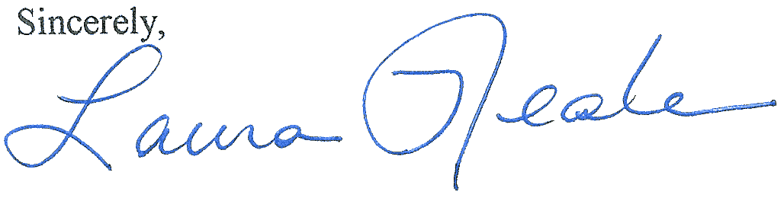
Laura Neale

