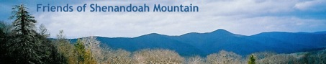

September 5, 2017

Mr. Glen Casamassa
Associate Deputy Chief
United States Forest Service
1400 Independence Ave, SW
Washington, DC 20250-1111

Re: Objection to Draft Decision (ROD) for Atlantic Coast Pipeline Project through the George Washington and Monongahela Forests

Dear Associate Deputy Chief Casamassa:

We are writing on behalf of Friends of Shenandoah Mountain (FOSM) to object to the USFS draft decision to approve the Atlantic Coast Pipeline (ACP). FOSM’s comments are focused on the Braley Pond – Hankey Mountain portion of the ACP route in western Augusta County, Virginia. The proposed ACP route is next to our proposed Shenandoah Mountain National Scenic Area, which has been recommended by the George Washington National Forest (GWNF) Land & Resource Management Plan. Our main concerns are that the draft decision;
- makes an exception to GWNF Plan standards and guidelines for construction of the ACP;
- bases conclusions on a faulty and inadequate EIS; and
- does not consider impacts on the proposed Shenandoah Mountain National Scenic Area.

About the Proposed Shenandoah Mountain National Scenic Area
Friends of Shenandoah Mountain is a coalition of organizations, businesses, and faith groups working toward permanent protection of the central Shenandoah Mountain area in the GWNF. Our goal is Congressional designation of a 90,000-acre tract of Shenandoah Mountain as a National Scenic Area with embedded Wilderness (see www.friendsofshenandoahmountain.org). Our proposal is the result of a 15-year collaborative effort involving diverse forest user groups that now has broad support by 300 organizations and businesses. The Shenandoah Mountain area has been identified as a prime candidate for permanent protection because it is so special. Stretching 72 miles through the heart of the GWNF, Shenandoah Mountain has the largest concentration of roadless areas on national forest land east of the Mississippi. This mostly unfragmented forest, which is exceptionally rich in biodiversity, is a local, regional, and national treasure.

The proposed SMNSA is an important water resource both for municipal water and to support aquatic life. It provides municipal water for Staunton and Harrisonburg and many other towns and cities downstream. It has headwaters of the James, Shenandoah and Potomac Rivers. Its coldwater streams are productive habitat for wild brook trout. Shenandoah Mountain is also a recreational hub for hiking, mountain biking, fishing, hunting, camping, horseback riding, nature study, and scenic driving. It serves the mid-Atlantic region’s recreational needs. Outdoor recreation on Shenandoah Mountain draws visitors to the area and supports the local tourism economy, as shown in Table 1. These figures have been increasing annually.

Table 1. Visitor Spending in 2015
Augusta County | $117 million
Staunton | $52 million
Rockingham County | $198 million
Harrisonburg | $114 million
Highland County | $17 million
Source: Virginia Tourism Corporation

Hankey Mountain: Part of Original SMNSA Proposal
The comments we have submitted to the Forest Service and FERC have focused on the segment of the ACP that crosses the GWNF in the Braley Pond – Hankey Mountain area which was part of the original Shenandoah Mountain National Scenic Area proposal submitted to the GWNF in October 2008 during the public comment period for the forest plan revision (see attached map). Since then, Friends of Shenandoah Mountain has modified our proposal boundaries to exclude the southern part of Hankey Mountain specifically to satisfy forest stakeholder concerns about the Grouse Habitat Management on Chestnut Oak Knob on the flank of Hankey Mountain. Specifically, game managers wanted to ensure that grouse management through timber sales would continue to be a priority on Chestnut Oak Knob where it has been a joint venture between Virginia Department of Game and Inland Fisheries and the Ruffed Grouse Society for several decades. While the pipeline corridor does not cross current SMNSA proposal boundaries, it does cross through the Grouse Management Habitat Area, and it would have significant negative effects on scenic qualities, recreation, forest fragmentation, and water resources of the SMNSA.

GWNF Plan Recommendation of SMNSA
The 2014 GWNF Land and Resources Management Plan recommends Congressional designation for the SMNSA: According to the Plan:
“the purposes of the Shenandoah Mountain Scenic Area are to:
- Ensure appropriate protection and preservation of the area's scenic quality, water quality, natural characteristics, and water resources;
- Protect and manage vegetation to provide wildlife and fish habitat consistent with the previously described purpose;
- Protect habitat for the Cow Knob salamander;
- Provide areas that may develop characteristics of old-growth forests; and
- Provide a variety of recreation opportunities that are consistent with the preceding purposes.

The Shenandoah Mountain National Scenic Area is well known for its scenic overlooks from the crest of Shenandoah Mountain, particularly Reddish Knob. Some of the best views on the North River Ranger District are possible from the crest of Shenandoah Mountain. Shenandoah Mountain has exceptional beauty and outstanding opportunities for solitude... The area provides clean drinking water; clean air; and erosion and flood control for Shenandoah Valley residents. It is a large, substantially unfragmented forest teeming with wildlife and home to neo-tropical songbirds, black bear, native trout, and a number of rare species including the Cow Knob salamander. There are abundant recreational opportunities, including camping, hiking, mountain biking, horseback riding, fishing, hunting, rockclimbing, and birding.”

Clearly, siting the ACP alongside the recommended Scenic Area is an inappropriate place for a new pipeline corridor. The GWNF Plan discourages new utility corridors: “When feasible, expansion of existing corridors and sites is preferable to designating new sites.” We object to the GWNF plan being amended to allow the pipeline to cross Rt. 250, Braley Pond access road. and Hankey Mountain.

Impacts of the ACP on the Proposed SMNSA
Scenic impacts
The EIS fails to adequately address scenic integrity impacts to the SMNSA. The pipeline crossing near the intersection of Rt. 250 and Rt. 715 (Braley Pond Rd) is a concern primarily because Rt. 250 is a major gateway to scenic and recreational resources on Shenandoah Mountain. Visitors form a first impression of the proposed SMNSA based on the visual experience from Rt. 250. A 125- to 175-foot wide construction corridor and 55-foot permanently-cleared corridor will significantly degrade the scenic quality of the southern end of the SMNSA.

According to the GWNF Plan, Rt. 250 is a “Scenic Corridor” (turquoise on Map 1) and GWNF land along this corridor will be managed to protect scenic values: “High quality scenery is provided in sensitive recreational and travelway settings…. The area visible during leaf-off for up to one-half mile from either side of the road typically defines the corridor… These areas are unsuitable for designation of new utility corridors, utility rights-of-way, or communication sites… The emphasis is on providing high quality scenery in sensitive recreational and travelway settings.” While the ACP route skirts the Rt. 250 Scenic Corridor management prescription, it is located squarely between the Scenic Corridor and the proposed SMNSA.

The Draft ROD states that the impacts will not meet the GWNF Plan’s “moderate” Scenic Integrity Objectives for the Hankey Mountain area. The EIS dismisses long-term visual effects. The ACP route would be clearly visible from several popular trails in the proposed Shenandoah Mountain National Scenic Area, including the Wild Oak National Recreation Trail on Hankey Mountain (green dot on right on Map 1) and Bald Ridge Trail in Ramseys Draft Wilderness (green dot on left on Map 1). It would also degrade the scenic quality of the Rt. 250 gateway to the following recreational resources:
- Braley Pond Recreation Area (fishing, picnicking, camping, biking, hiking, hunting, horseback riding, and nature study are popular in this area)
- Dowells Draft (popular for grouse hunting, hiking, mountain biking, horseback riding)
- Hankey Mountain (hiking, hunting, mountain biking, horseback riding, nature study)
- Staunton Dam and Elkhorn Lake (fishing, photography, canoeing, birding, hiking, mountain biking, horseback riding)
- Upper North River (hiking, horseback riding, camping, fishing, hunting, mountain biking, nature study)
- Todd Lake Campground (camping, swimming, picnicking, hiking, mountain biking)
- North River Campground (camping, fishing, hiking, mountain biking, horseback riding, hunting)
- Ramseys Draft Wilderness, one of Virginia’s most popular Wilderness areas (hiking, backpacking, fishing, hunting, camping, birding
- Confederate Breastworks (hiking, learning history, viewing outstanding scenery, birding, hunting, mountain biking

Map 1. Scenic Integrity Impacts of the ACP and Access Roads on the SMNSA and Wild Oak National Recreation Trail
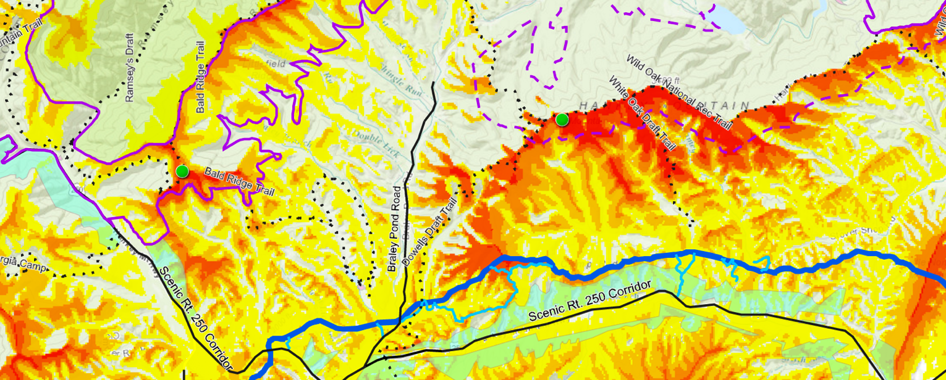
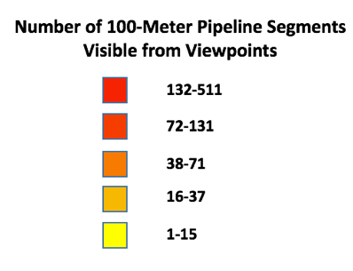
Stream Impacts
The Draft ROD dismisses effects on brook trout streams crossed by the ACP and access roads and fails to discuss impacts on all sensitive streams. The Shenandoah Mountain area is a regional stronghold for wild brook trout. The ACP route crosses four brook trout streams in the Braley Pond-Hankey Mountain area (shown on Map 2):

- Braley Branch
- Calfpasture River
- Dowell’s Draft
- White Oak Draft

Construction of the pipeline will harm these sensitive brook trout streams by causing siltation and turbidity. It would also increase stream channel bed and bank erosion because of increased runoff.

Map 2. ACP Route through High Integrity Wild Brook Trout Habitat in the Braley Pond – Hankey Mountain area. Brook Trout streams are highlighted in blue.
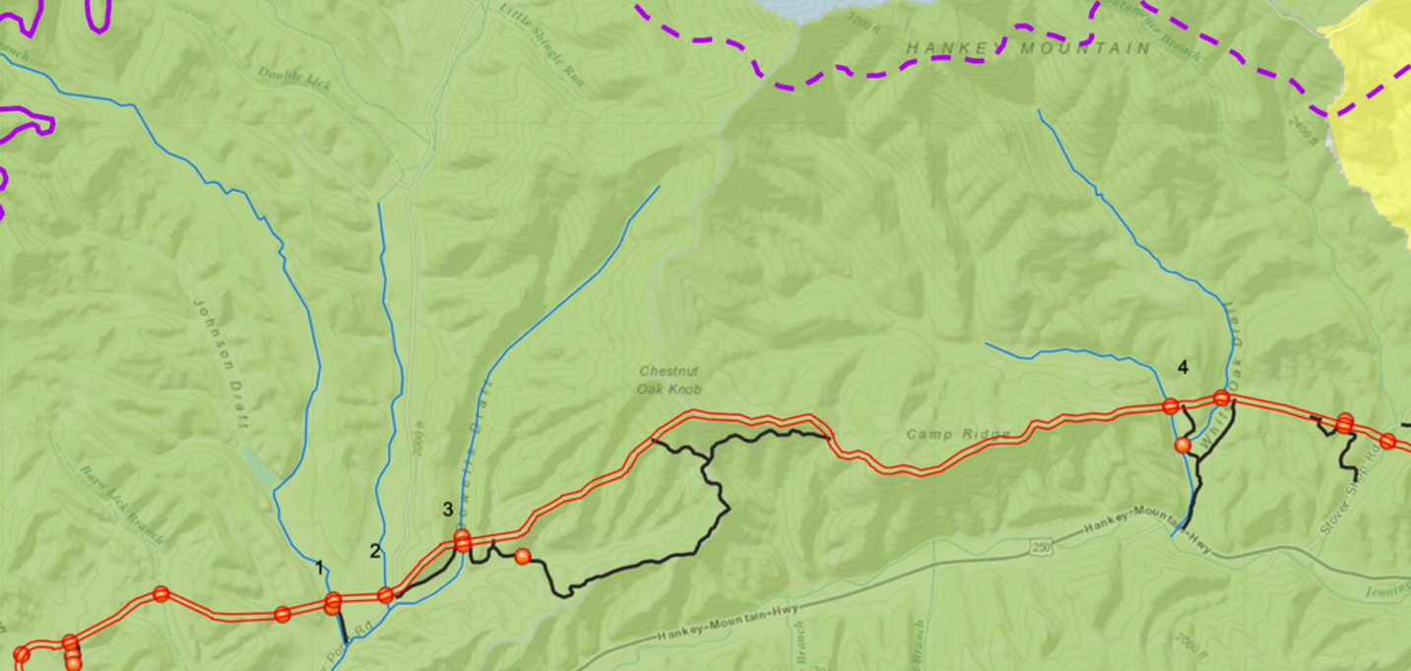
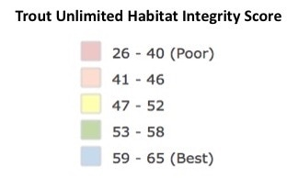

In a Sept. 1, 2016 letter to FERC the Forest Service expressed concern about project impacts to White Oak Draft and a Dowell's Draft tributary to the Calfpasture River, both wild brook trout streams. The Forest Service specifically asked Dominion/ACP to "re-evaluate its proposed stream crossings and proposed locations of access roads, while considering Forest Plan standards and BMPs relating to soil and water." The EIS ignores this official request and continues to show the ACP route and access roads crossing these sensitive streams. We object to the USFS ignoring Dominion’s lack of response to this request and approving the project anyway.

High Hazard Area
The Forest Service has identified White Oak Draft as a "High Hazard Area" because of steep slopes (>70%) adjacent to the stream (see #4 on Map 2). Construction of the pipeline across this deep ravine would damage the stream and set the stage for landslides during heavy rains. Dominion has failed to respond to the Forest Service’s request for detailed construction plans on how they could safely and responsibly construct the pipeline across White Oak Draft and what measures they would use to stabilize slopes and control soil erosion. We object to the USFS making a decision to approve the pipeline without Dominion providing an acceptable site specific slope hazard mitigation plan.

Recreation Impacts
The scenic Rt. 250 gateway is perhaps the most heavily used access to prime recreational resources located in or adjacent to the proposed Shenandoah Mountain National Scenic area (shown on Map 3):
- campgrounds
- lakes
- picnic areas
- 150 miles of trails
  - Wild Oak National Recreation Trail
  - Shenandoah Mountain Trail (a segment of the Great Eastern Trail)
- Ramseys Draft WIlderness
- Fort Edward Johnson (Confederate Breastworks)
The EIS for the ACP project does not discuss or evaluate these potential impacts, and the Draft ROD ignores these important impacts.

Map 3: Rt. 250 is a primary access to recreational sites and trails within or just outside of the SMNSA
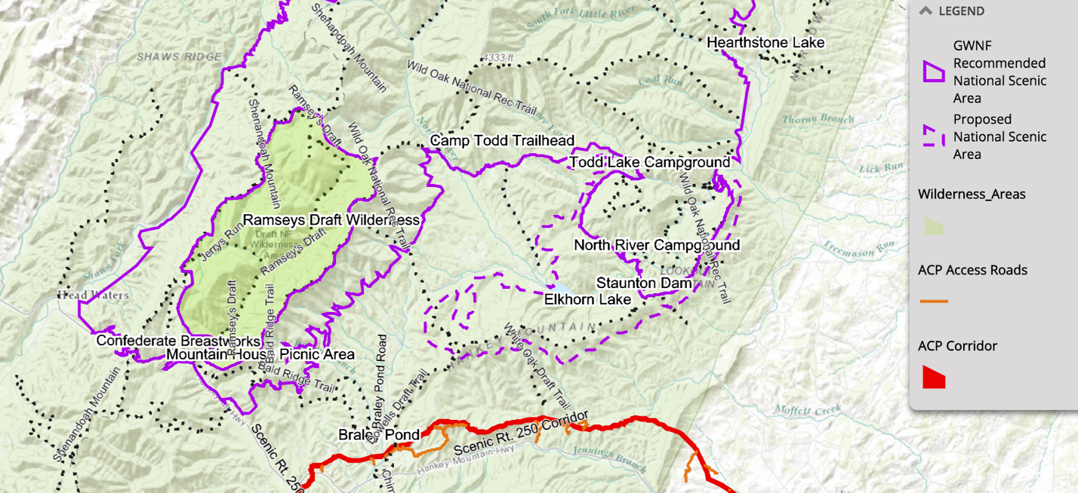

Forest fragmentation impacts
A permanent ACP corridor across Hankey Mountain would fragment three miles of core forest causing loss of 535 acres of high quality interior forest habitat. This includes the width of the 125-foot construction corridor plus 100 meters on each side (shown on Map 4). Access roads would cause loss of an additional 124 acres of core forest. This route through core forest on Hankey Mountain is the longest continuous stretch of forest fragmentation on National Forest land for the entire ACP. The core forest on Hankey is of the highest quality category, >500 acres. The new cleared corridor and roads would create a pathway for nonnative invasives that outcompete native species and invite harmful predators to move into the forest "edge" and spread into the proposed National Scenic Area. The EIS concludes that “forested areas would experience significant impacts as a result of fragmentation.” Given this conclusion, the USFS draft decision to permit the ACP sets the stage for irreparable harm to interior forest habitat integrity.

The portion of the GWNF between Rt. 250 and Rt. 33 is the largest tract of mostly unfragmented forest on National Forest land east of the Mississippi; therefore, this fragmentation would be particularly significant.

Map 4. Fragmentation and loss of core forest habitat on Hankey mountain
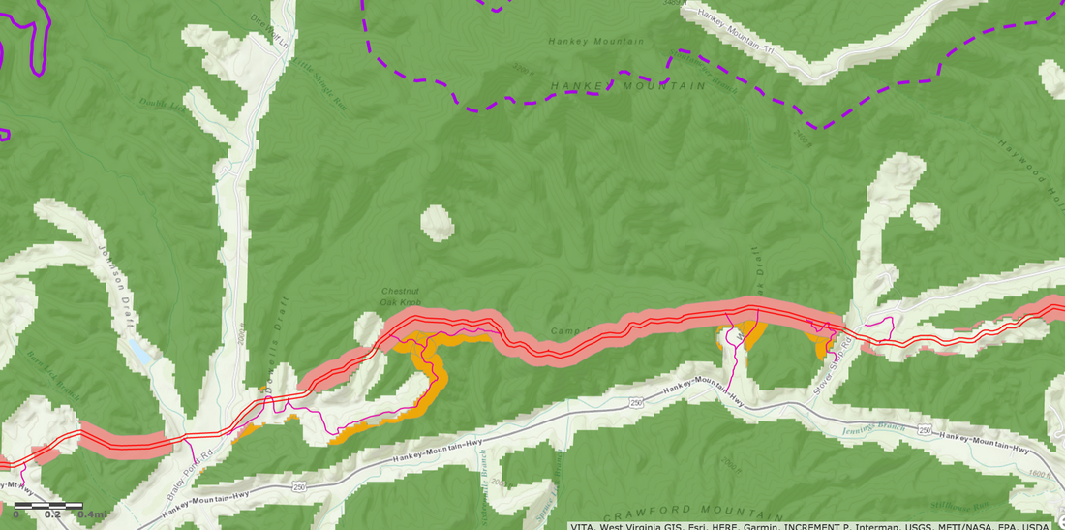
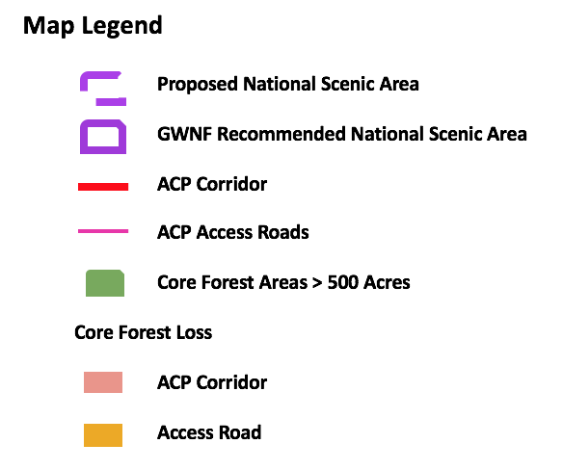

Conclusion
We are concerned that the ACP would degrade visual qualities, recreational opportunities, wild brook trout streams, and interior forest habitat and could even jeopardize the viability of the proposed National Scenic Area for Congressional designation.

Given these concerns, Friends of Shenandoah Mountain objects to the USFS draft decision to make exceptions to GWNF Plan requirements and approve the ACP. The flawed EIS does not provide a sufficient basis for the Forest Service to make a decision on whether to issue a Special Use Permit and waive Forest Service standards to protect water, old growth, and scenic integrity. This route passes through one of the finest and least fragmented natural areas remaining in the Eastern United States, an area that is recommended for congressional designation by the USFS and broadly supported for protection by the public. We ask that the USFS reconsider its decision and deny a special use permit for the ACP.

Thank you the opportunity to object.

Sincerely,
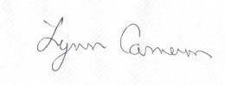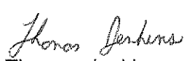
Lynn Cameron Thomas Jenkins
Co-Chair Co-Chair
5653 Beards Ford Rd. 375 E. Wolfe St.
Mt. Crawford, VA 22841 Harrisonburg, VA 22802
(540) 234-6273 (540) 437-9000
slynncameron@gmail.com tj@shenandoahbicycle.com

Attachment: Proposed Pipeline Route and Shenandoah Mountain

