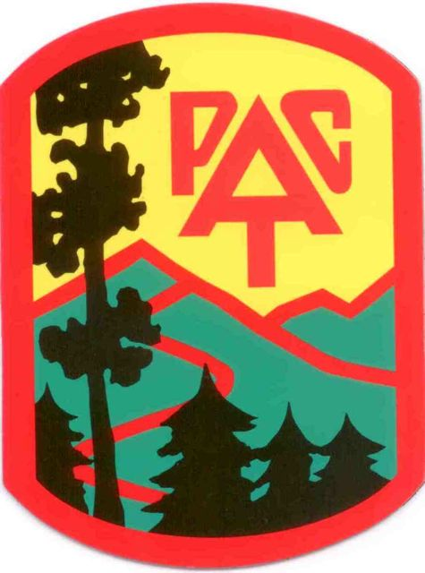
Southern Shenandoah Valley Chapter
September 5, 2017

Mr. Glen Casamassa
Associate Deputy Chief
United States Forest Service
1400 Independence Ave, SW
Washington, DC 20250-1111

Re: Objection to Draft Decision (ROD) for Atlantic Coast Pipeline Project through the George Washington and Monongahela Forests

Dear Associate Deputy Chief Casamassa:

I am writing on behalf of the Potomac Appalachian Trail Club – Southern Shenandoah Valley Chapter (PATC-SSVC) to object to the USFS draft decision to allow the Atlantic Coast Pipeline (ACP) to pass through 21 miles of the George Washington (GWNF) and Monongahela National Forests (MNF). The Draft Record of Decision is based on a flawed EIS that does not adequately assess the environmental effects of the proposed ACP, and it amends the forest plans to exempt the ACP from plan requirements.

From the beginning of the process involving Dominion Resources’ application to build the ACP, SSVC has felt like the GWNF and MNF officials were being responsible stewards of our public lands and taking a careful look at the impacts of this mega-pipeline. Then all of a sudden, the USFS turned in a different direction by issuing a draft ROD that relinquished responsibility for managing the GWNF and MNF in a manner that follows the forest management plans, laws, and regulations. This draft decision undermines important benefits our national forests provide to the American public. The USFS has given the ACP a free pass to slice through our national forests and cause untold harm to habitat, water resources, recreation, and scenic beauty, and all this without any credible demonstration of public need for the project.

PATC-SSVC is located in the Shenandoah Valley of Virginia in the Harrisonburg-Staunton-Waynesboro area. Our club leads hikes and maintains trails along the 16-mile route of the Atlantic Coast Pipeline through the George Washington National Forest (GWNF). In addition to hiking, PATC-SSVC typically does 1,000-2,000 hours of volunteer work on trails in the Shenandoah Mountain area of the GWNF each year.

When we hike, we enjoy scenic views, cascading mountain streams, wildflowers, birds, and geologic features, and we especially appreciate the large, unfragmented tracts of national forest on the Blue Ridge Mountains and Shenandoah Mountain. These tracts of wildlands offer supreme hiking experiences not just for our club, but for the 10 million people who live within a two-hour drive of the GWNF. The ACP route cuts through some of the premier areas of the national forest for scenic beauty, nature study, and outdoor recreation, including backpacking, birding, fishing, hunting, and mountain biking.

Our Conservation Committee reviewed the EIS for the ACP and found it to be incomplete and very misleading. Some of the most essential information for a responsible decision is missing. Following is a list of our major concerns:

- Scenic Integrity: The EIS either fails to adequately analyze or dismisses impacts on scenic integrity in the GWNF, particularly around:
- Appalachian Trail and Blue Ridge Parkway – The HDD western entrance, access road, and staging area will dominate the scenic view from Torry Ridge Trail in the Sherando Lake Recreation Area. The EIS mentions and dismisses scenic effects on Torry Ridge Trail. The pipeline route will be visible from many points along the Parkway and AT, including Three Ridges Overlook, Ravens Roost Overlook, Cedar Cliffs Overlook, Humpback Rocks, and Bee Mountain. This area is heavily used for hiking, backpacking, nature study, and scenic driving. The EIS mentions Three Ridges Overlook, Ravens Roost, and Cedar Cliffs and omits all the others, a clear deficit in the analysis.
- Hankey and Shenandoah Mountains – The pipeline will be visible from many overlooks in the proposed Shenandoah Mountain National Scenic Area, including Bald Ridge Trail in Ramseys Draft Wilderness and Wild Oak National Recreation Trail on Hankey Mountain. The EIS states that the impacts will not meet the “moderate” Scenic Integrity Objectives in the GWNF Plan. The EIS dismisses long-term visual effects.

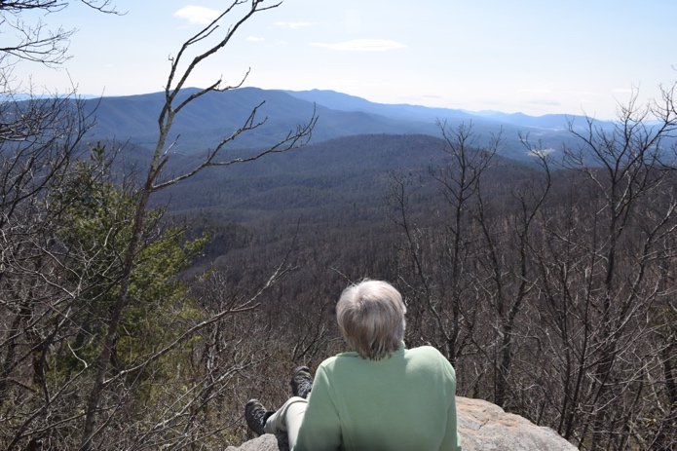
The ACP Corridor would bisect the viewshed of Chestnut Oak Knob in the middle ground as seen from Wild Oak National Recreation Trail on Hankey Mountain. Photo by Malcolm Cameron

- Trails South of Rt. 250 The ACP will mar scenic beauty seen from trails on Crawford Mountain, Elliott Knob, and southern Shenandoah Mountain, including Shenandoah Mountain Trail, a segment of the Great Eastern Trail, American’s newest long distance trail. The EIS says the SMT crossing will not be consistent with a “moderate” Scenic Integrity Objective. The USFS dismisses this effect and lowers the standard to “low”. Considering the incredible beauty of the southern Shenandoah Mountain areas and the popularity of the SMT, this is an irresponsible conclusion. Visual quality of trails on Elliott Knob and Crawford Mountain are not discussed in the EIS, a serious omission. We lead hikes on these trails, and we know the corridor to be visible.
- Proposed Shenandoah Mountain National Scenic Area (SMNSA) PATC-SSVC is a strong advocate for Congressional designation of the the proposed SMNSA. We hike on Shenandoah Mountain and in Ramseys Draft Wilderness to enjoy the wild beauty and solitude the area offers. Our members maintain trails in Ramseys Draft Wilderness, including Bald Ridge Trail. The ACP would be clearly visible from all the best overlooks on Bald Ridge and Hankey Mountain. The ACP route would follow along and then cross Dowell’s Draft Trail and White Oak Draft Trail. We concur with comments submitted by Friends of Shenandoah Mountain on March 24, 2017, regarding scenic impacts, forest and stream impacts, and recreation impacts on the proposed SMNSA. We also share their concern that the pipeline could mar the proposal and threaten its viability to be designated by Congress.

- Recreation Resources
  - Sherando Lake Recreation Area: This is the most popular developed recreation site in the GWNF. The ACP would permanently degrade the scenic entrance to the recreation area, as the pipeline corridor follows Mt. Torry Rd. The EIS admits impacts on Sherando Lake Recreation Area will harm visual integrity, but dismisses these impacts. Mitigation will not be adequate.
  - Braley Pond Day Use Area: The ACP route crosses the Braley Pond access road, permanently degrading the scenic beauty that attracts so many fishermen, campers, hikers, mountain bikers, and naturalists. It would also fragment the forest around Braley Pond, providing a pathway for invasives. The EIS discusses the ACP crossing of the entrance road and acknowledges it will be highly visible, but concludes the area would still meet the “moderate” Scenic Integrity Objective. This is not a fair conclusion. The EIS does not mention impacts on the Braley Pond Day Use Area.

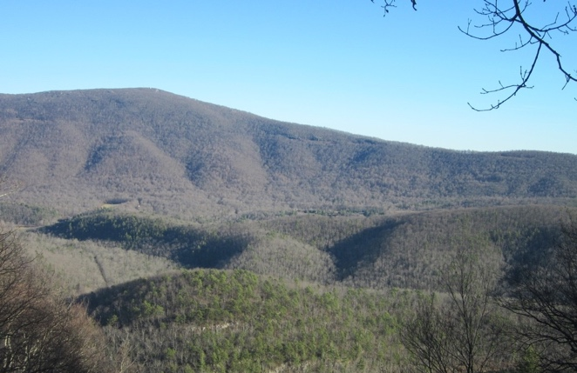
View of western HDD entry point from Torry Ridge Trail in the Sherando Area. Photo by Malcolm Cameron

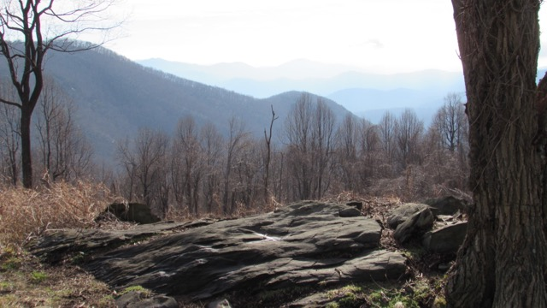
View of Piney Mountain from Three RidgesOverlook on AT. Photo by Mike Waterman

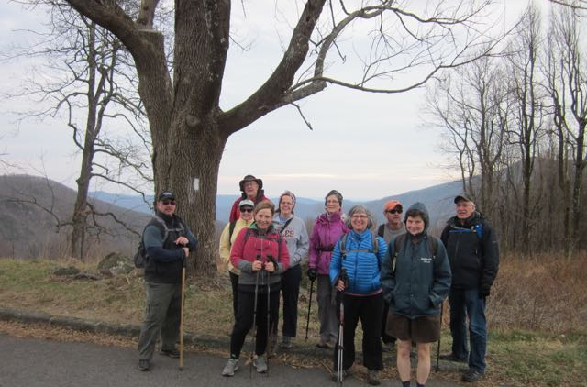
SSVC hikers on AT near ACP crossing. Photo by Lynn Cameron

- Biodiversity: The Shenandoah Mountain area of the GWNF stands out as a “Biodiversity Hotspot” identified by The Nature Conservancy. The US Fish & Wildlife Service has identified 30 federally threatened or endangered species (TES), 2 designated critical habitats, 1 proposed species, 5 proposed critical habitats, and 6 species under review for federal listing that are known to occur along the ACP route. The EIS does not contain a survey for the Rusty Patch Bumble Bee and therefore cannot inform the Forest Service decision on whether to issue a Special Use Permit. The RPBB has been sighted on several occasions in summer of 2017 along the pipeline corridor in the vicinity of Duncan Knob in Bath County. U.S. Fish & Wildlife Service would also need survey results to inform its recommendations for the project.
- Forest Fragmentation: According to the Virginia Department of Forestry, "Loss of forested acres and the fragmentation of the remaining acres reduces the potential of the forest to provide the economic, social and ecological benefits that we depend on." The core forested areas along the ACP route are a diminishing resource. The route cuts through 21 miles of our national forests chopping up 20 large core forest areas where biodiversity is the highest and harm to the interior forest from fragmentation and "edge effect" would be the greatest. An analysis of the ACP route through our national forests revealed that 2451.5 acres of high value core forest habitat would be lost to fragmentation from construction of the pipeline and access roads. For the entire route 14,786 acres of interior forest would be lost. Fragmentation will negatively impact many special species, such as migratory birds, pollinators, amphibians, reptiles, and mammals that need interior forest habitat. Fragmentation by 19 miles of access roads in our national forests alone compounds the problem. The EIS acknowledges that the ACP will cause fragmentation that will have "significant impacts" on habitats. FERC states in the EIS that forest fragmentation caused by the pipeline cannot be mitigated, yet it maintains the ACP will not result in "significant" cumulative impacts. There is no basis for this conclusion.
- Water Resources: The ACP route crosses 26 native brook trout streams in the GWNF alone. The EIS dismisses impacts on these streams. PATC-SSVC is particularly concerned about streams in the Hankey Mountain – Braley Pond area: Braley Branch, Calfpasture River, Dowells Draft, and White Oak Draft. These are streams where we have been leading hikes for over 30 years.
- Lack of Need: A major weakness of the EIS is that it so readily accepts the necessity of the project, even though this has been challenged by an independent study by Synapse Energy, Are the Atlantic Coast Pipeline and the Mountain Valley Pipeline Necessary? (Sept. 2016), that concludes that both the ACP and MVP are unnecessary and that existing pipelines, with modifications, can meet future demand through 2030.
- Cumulative Impact of Multiple Pipelines. With multiple pipelines across the AT and Blue Ridge Parkway being proposed, it seems reasonable to consider cumulative impacts of all these pipelines, but the EIS does not do this. The USFS should insist that FERC conduct such an analysis of cumulative impacts of multiple pipelines and should refuse to approve any pipeline through our national forests until this is done.
- Insufficient Alternatives: Another weakness is that the EIS does not give serious consideration to an alternative that avoids the national forests or that co-locates this new utility with existing utility corridors. The EIS conclusion that a 21-mile route through both forests is an acceptable option is not well supported. These two national forests are strongholds for biodiversity, native brook trout, clean water, recreational resources, and scenic beauty. The EIS gives too much credence to mitigation and dismisses cumulative impacts related to these important values that our national forests provide.
- High Hazard Areas: The EIS identified over 100 possible slope instability hazard locations along the proposed ACP route. Of these it identified 46 areas that met the criteria for further evaluation as geohazards. The Forest Service asked Dominion to provide detailed plans for 10 high-hazard areas that combined steep slopes, unstable soils, and problematic bedrock types. These conditions set the stage for severe erosion and harmful stream sedimentation, particularly during severe rain events. The most significant event was Hurricane Camille in 1969, but severe rainfall events that cause landslides happen every 11 years on the average. One of the “high hazard” areas is in the White Oak Draft area of Hankey Mountain which has >80% slope. See USFS letter, Oct. 24, 2016. Dominion has not provided enough detailed analysis and site-specific mitigation plans for the 10 areas to provide adequate information for the Forest Service to make a decision on whether to issue a Special Use Permit. Dominion provided slope stability analyses and proposed mitigation measures for only 2 of the 10. The USFS cannot in good conscience approve the project without more thorough analysis that covers all the potential landslide areas.

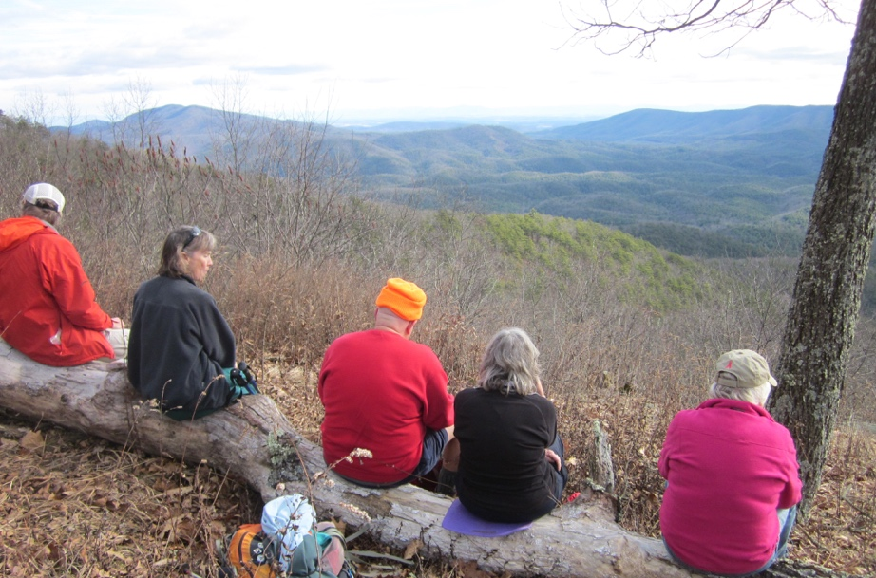
The proposed Shenandoah Mountain National Scenic Area would be marred by the ACP; the pipeline route would bisect this viewshed from Bald Ridge Trail in Ramseys Draft Wilderness. Photo by Lynn Cameron

The ACP is putting many fragile resources in the GWNF at great risk. The USFS has come to the wrong decision to make exceptions to plan requirements for the ACP and approve the project. We strongly object to this decision.

Thank you for the opportunity to object.

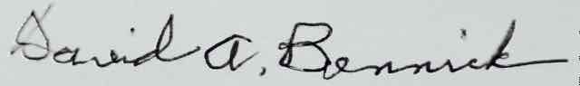

David Bennick
President
Potomac Appalachian Trail Club – Southern Shenandoah Valley Chapter
286 Cranberry Drive
Stuarts Draft, VA 24477
dbennick@verizon.net
(540) 337-5330
www.ssvc.org

