Victoria and Christopher Vacher
1496 Hankey Mountain Highway
Churchville, VA 24421
(540) 337-6795
(757)617-5679

The United States Forest Service
George Washington and Jefferson National Forests
Monongahela National Forest
5162 Valleypointe Parkway
Roanoake, VA 24019-3050

September 1, 2017

RE: OBJECTION to the Record of Decision for Atlantic Coast Pipeline Project through the George Washington and Monongahela Forests to Associate Deputy Chief Glen Casamassa

Associate Deputy Chief Glen Casamassa, Forest Supervisors, and USFS Staff:

We have sent multiple correspondences to the Federal Energy Regulatory Commission (FERC), The United States Forest Service (USFS), as well as other state and municipal regulatory agencies.

The last letter that we sent the USFS regarding the proposed Atlantic Coast Pipeline was dated March 8, 2016. In that correspondence we stated (cut and pasted), “If you allow a forty-two inch natural gas pipeline to be constructed through the George Washington National Forest, it would unquestionably guarantee an onslaught of applications seeking to drill for natural gas, and for the construction of tie-in lines, within the proximity of the proposed ACP for generations. A similar phenomenon can be observed in suburban/urban areas when a new highway is proposed. Businesses compete to establish locations near the new conduit.
You, the USFS, are not concerned with suburban/urban development. You are tasked with forest protection, the safeguarding of rare and endangered species, global deforestation issues, wildlife habitat preservation/management, protection of wilderness areas, management of public water and timber, preservation of lands for hunting and fishing, and a list of additional responsibilities that encompasses the welfare of a much larger populace. Your judgment will affect millions of Americans, the Earth, and generations yet to come. “

The motto of the USFS is, “Caring for the Land and Serving People”.
In your online announcement, USDA Forest Service Issues Draft Decision to Permit the Atlantic Coast Pipeline Project on National Forests in West Virginia and Virginia, you state, “This proposed decision would support federal policies emphasizing energy infrastructure, jobs, economic growth and our agency’s efforts to provide for multiple use.”

Jobs, economic growth, and infrastructure are not the responsibility of the USFS! Your job is to protect the natural resources that have been placed under your stewardship, and the Americans that rely on those natural resources.

Some of the “Guiding Principles” that are listed on the USFS website include:

- We use the best scientific knowledge in making decisions and select the most appropriate technologies in the management of resources.
- We are good neighbors who respect private property rights.
- We strive for quality and excellence in everything we do and are sensitive to the effects of our decisions on people and resources.
- We promote grassroots participation in our decisions and activities.
- We maintain high professional and ethical standards.
- We are responsible and accountable for what we do.

You are aware that the GWNF contains the headwaters, recharge areas, and reservoirs for household water supplies and farm irrigation, that millions of people in Virginia and Washington D.C rely on. How could allowing an herbicide-maintained right of way (ROW), and multiple access roads to be constructed “help” protect those resources?

Does being a “good neighbor” include allowing Dominion to usurp NATIONAL forest land? Please take the time to genuinely consider your decisions. Do not be intimidated. You are being shoved and pressured by many parties. We don’t expect urban bureaucrats in Washington D.C. to respect the land. It takes people like you to protect our heritage. Do not give up your principles.

Allowing the proposed pipeline and access roads would cause adverse affects on many protected species. It would fragment some of the best wildlife habitat on the east coast. Permanent removal of all those carbon-sequestering trees for a natural gas conduit would be moving in exactly the opposite direction of fighting climate change.

You know the damage that allowing this proposed pipeline would cause. Should you allow this ruinous pipeline, at very least require that it be routed in a sensible path that causes the least amount of damage to the national forest. Heading north out of Deerfield, VA back toward Shenandoah Mountain is flat out stupid. The pipeline should pass further south of Deerfield, and continue along a straight southeastern path to minimize use of the national forest.

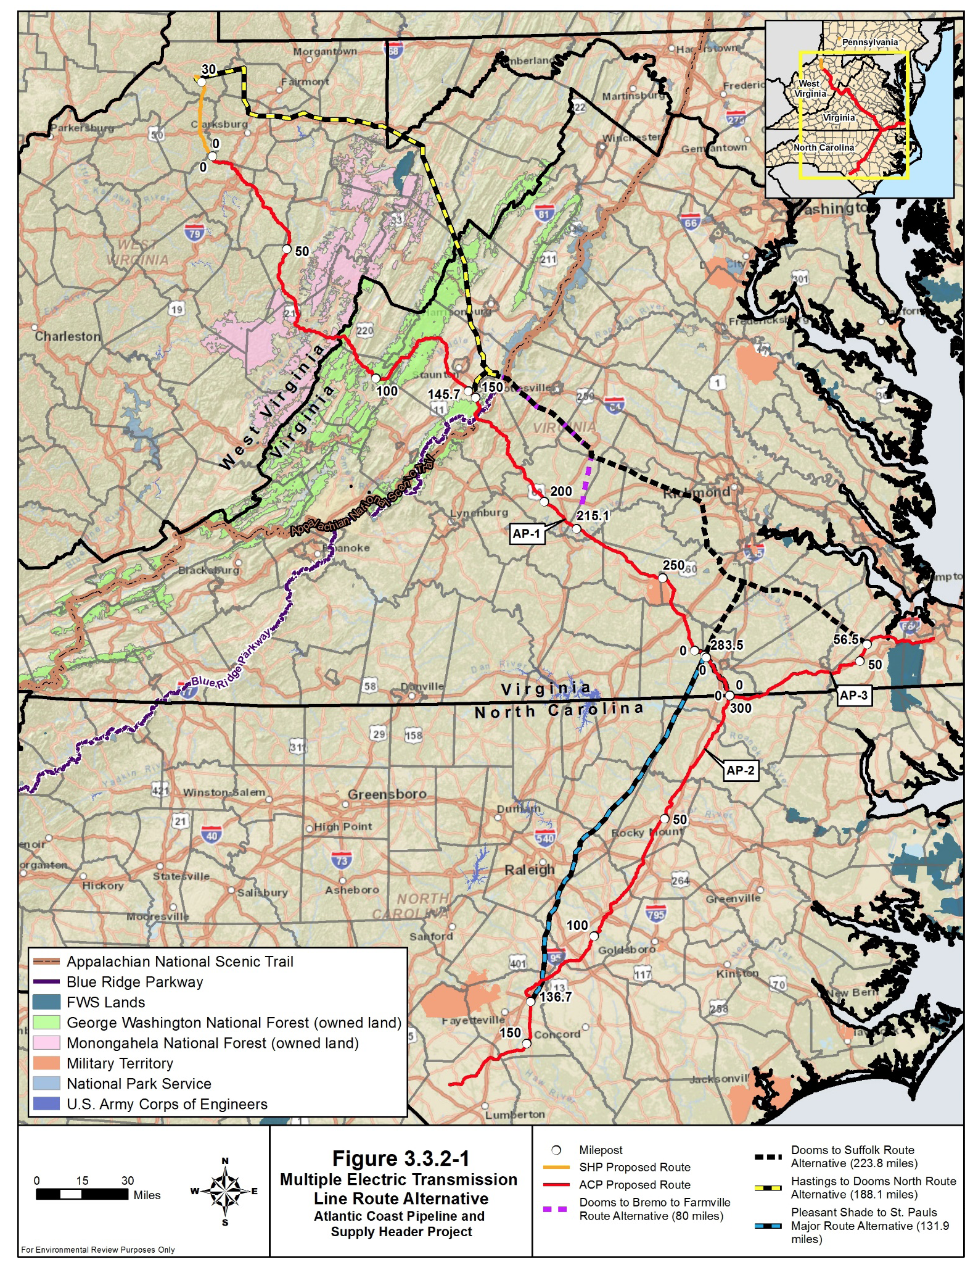

Turning north here is ridiculous!
Turning north here is ridiculous!

A straight line would reduce the impact on the GWNF

Routing further south would minimize encroachment through the GWNF

Keep in mind that Dominion already has a history of environmental and regulatory violations. We have included some examples at the conclusion of this letter. If you allow this pipeline to be constructed you would be opening our forests to soil compaction, fuel and oil leaks, ongoing water pollution due to increased runoff and herbicide applications, damage to waterways, negative impacts on protected species, creating a vector for invasive species, risk of explosion/failure where none currently exists, and habitat fragmentation! How does this fit with, “Caring for the Land”?

In addition to the permanent environmental damage that the proposed pipeline would cause, it would be detrimental to the viewsheds of the National Forests, The Great Eastern Trail, The Blue Ridge Parkway, and the Appalachian Trail. It is incomprehensible why the USFS would even be considering this project!

With our most sincere convictions we request that you deny Dominion permission to construct the proposed Atlantic Coast Pipeline, because it is the right thing to do. We the people are disgusted and appalled with wealthy corporate interests exploiting our common resources, destroying the environment, killing millions of carbon-sequestering trees, polluting our waters, and seizing our public and private lands through eminent domain for the profit of a few executives and shareholders. Deny this permit because, IT IS THE RIGHT THING TO DO!

REMEMBER, the motto of the USFS is, “Caring for the Land and Serving People”.

A copy of this page with our signatures is located on the final page of the document.

_________________________________________________
Victoria L. Vacher

_________________________________________________
Christopher N. Vacher

Dominion already has a terrible record of polluting water and air, and has been fined by multiple agencies, for multiple violations.
You can read a full report of the following info at: http://www.dep.wv.gov/pio/Documents/Settlements%20and%20Orders/DOMINION%20TRANSMISSION%20INC.pdf
October 1, 2012: Dominion caused conditions not allowable in waters of the State by creating sediment deposits in and Unnamed Tributary (UT) of Battle Run at or near N40º06.535’W80º35.297’
November 8 and 9, 2012: Dominion caused conditions not allowable in waters of the State by creating sediment deposits at the following locations:
- Sims Run located at or near N39º45.816”W80º50.473”
- A UT of Little Tribble Creek (SWV-JSL-030) located at or near N39.827821º W80.768483º
- A UT of Little Tribble Creek (SWV-JSL-037) located at or near N39.834616º W80.763886º
- A UT of Grave Creek located at or near N39º50.976’W80º43.974’
- Bartletts Run located at or near N39º52.454’ W80º41.072’
- A UT of Leach Run located at or near N39º54.629’ W80º40.966’
- A UT of Little Toms Run located at or near N39º53.953’W80º41.256’
- A UT of Grave Creek located at or near N39º57.424’W80º39.624’
March 11, 2013: Dominion caused conditions not allowable in waters of the State by creating sediment deposits in Sims Run located at or near N 39° 45.816 W 80° 50.473".
March 13, 2013: Dominion caused conditions not allowable in waters of the State by creating sediment deposits at the following locations:
- A UT of Long Run located at or near N39°47'20.92" W80048'27.00".
- ii. A UT of Little Tribble Creek located at or near N39°49'38.71" W80046'08.17''. Sediment controls were also observed in the UT.
- A UT of Little Tribble Creek located at or near N39°50'00.92"
- W80045'50.36". Sediment controls were also observed in the UT.
March 18, 2013: Dominion caused conditions not allowable in waters of the State by creating distinctly visible settleable solids in Middle Run located at or near N39°16'05.90" W80048'14.89".
May 14, 2013: Dominion caused conditions not allowable in waters of the State by creating sediment deposits in Bartletts Run at or near N39°52.3772' W80041.1271'.

Sediment control devices were also observed in the stream
January 15, 2014: WVDEP received a Spill Report (HSEM Ref No. 2116-A) regarding produced water leaking from an undetermined location at the Lightburn Compressor Station near Lightburn, West Virginia. As a result of the investigation, it was determined that underground pipelines associated with the plant were leaking outside of secondary contaimilent. To date, remediation is on-going, and Dominion is in the process of submitting a sampling plan to WVDEP. Dominion represents that it has a Groundwater Protection Plan for the Lightburn Compressor Station, which is kept on-site and available.

February 5, 2014:
- Dominion caused conditions not allowable in waters of the State by creating distinctly visible settleable solids. Specifically, a break in pipeline H-3904 located at or near GPS coordinates 39º 11.3163' N, 80º 35.2317'W released crude oil and produced water into Dry Fork. Dominion and/or a contractor under its guidance and/or direction failed to provide sufficient protection to prevent crude oil and produced water from entering Dry Fork.
- Dominon failed to report to the Office of Water Resources' Emergency Notification Number any non-compliance, which may have endangered health or the environment immediately after becoming aware of the circumstances.
- Dominion failed to immediately take all measures to contain the spill caused by the H-3904 pipeline break.
February 28, 2014: Dominion caused conditions not allowable in waters of the State by creating sediment deposits in a UT of Grave Creek at or near N 39º50.7328' W 80º 44.0825'.
April 1, 2013: The Department of Justice and the U.S. Environmental Protection Agency (EPA) announced today that Dominion Energy has agreed to pay a $3.4 million civil penalty and spend approximately $9.8 million on environmental mitigation projects to resolve Clean Air Act (CAA) violations. http://www2.epa.gov/enforcement/dominion-energy-inc
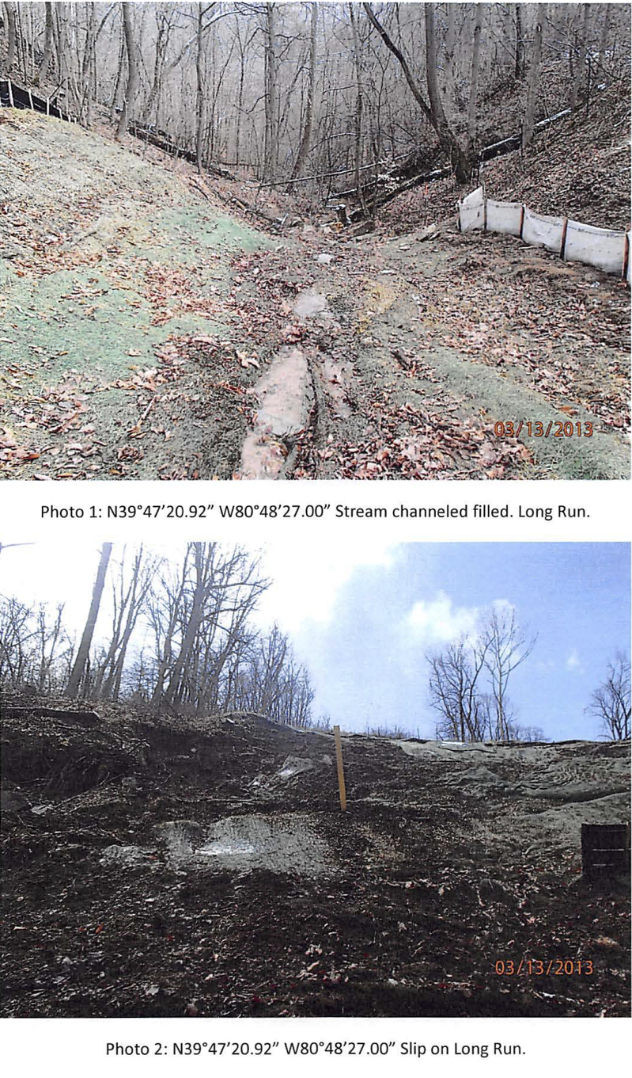
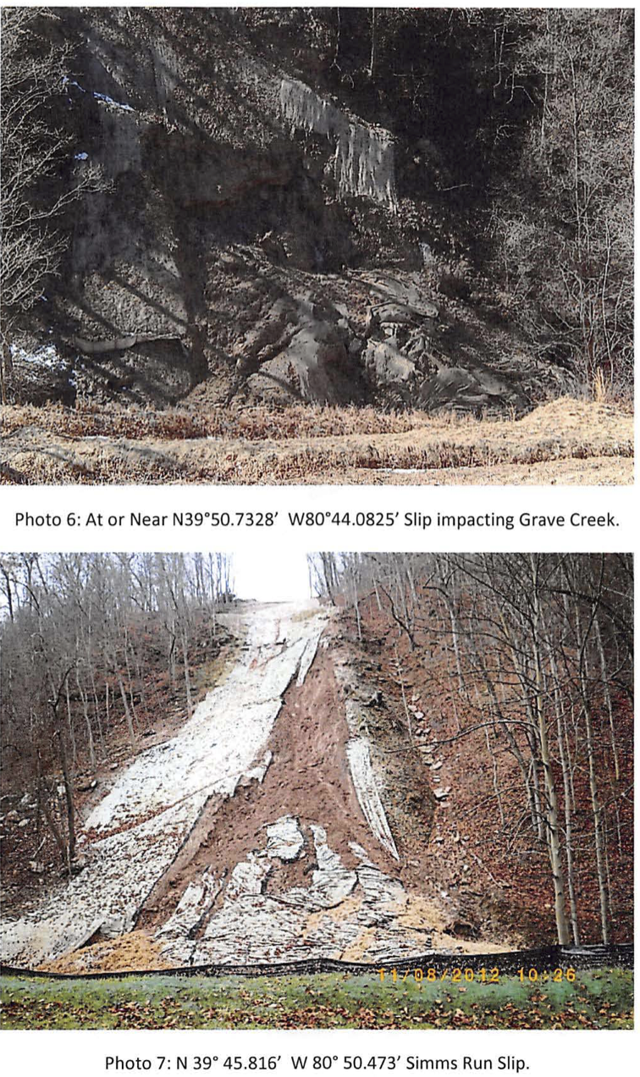

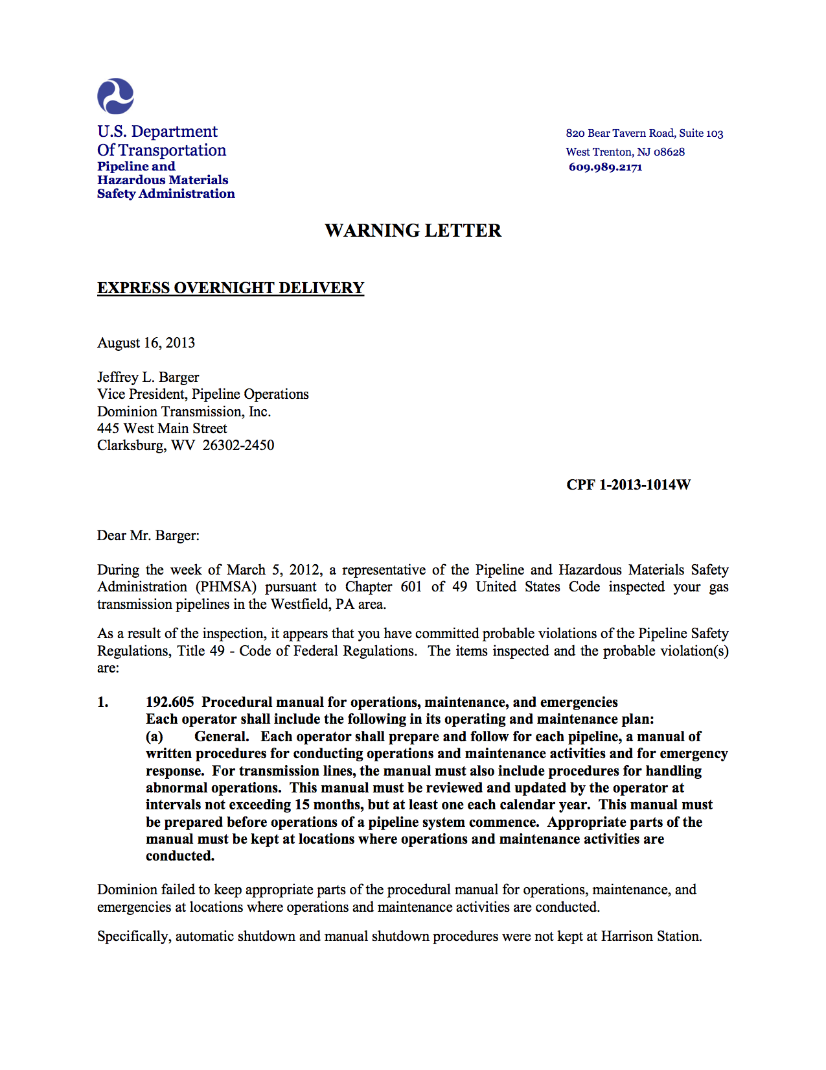
The following letter from the U.S. DOT can be read at: http://primis.phmsa.dot.gov/comm/reports/enforce/documents/120131014W/120131014W_Warning%20Letter_08162013_text.pdf

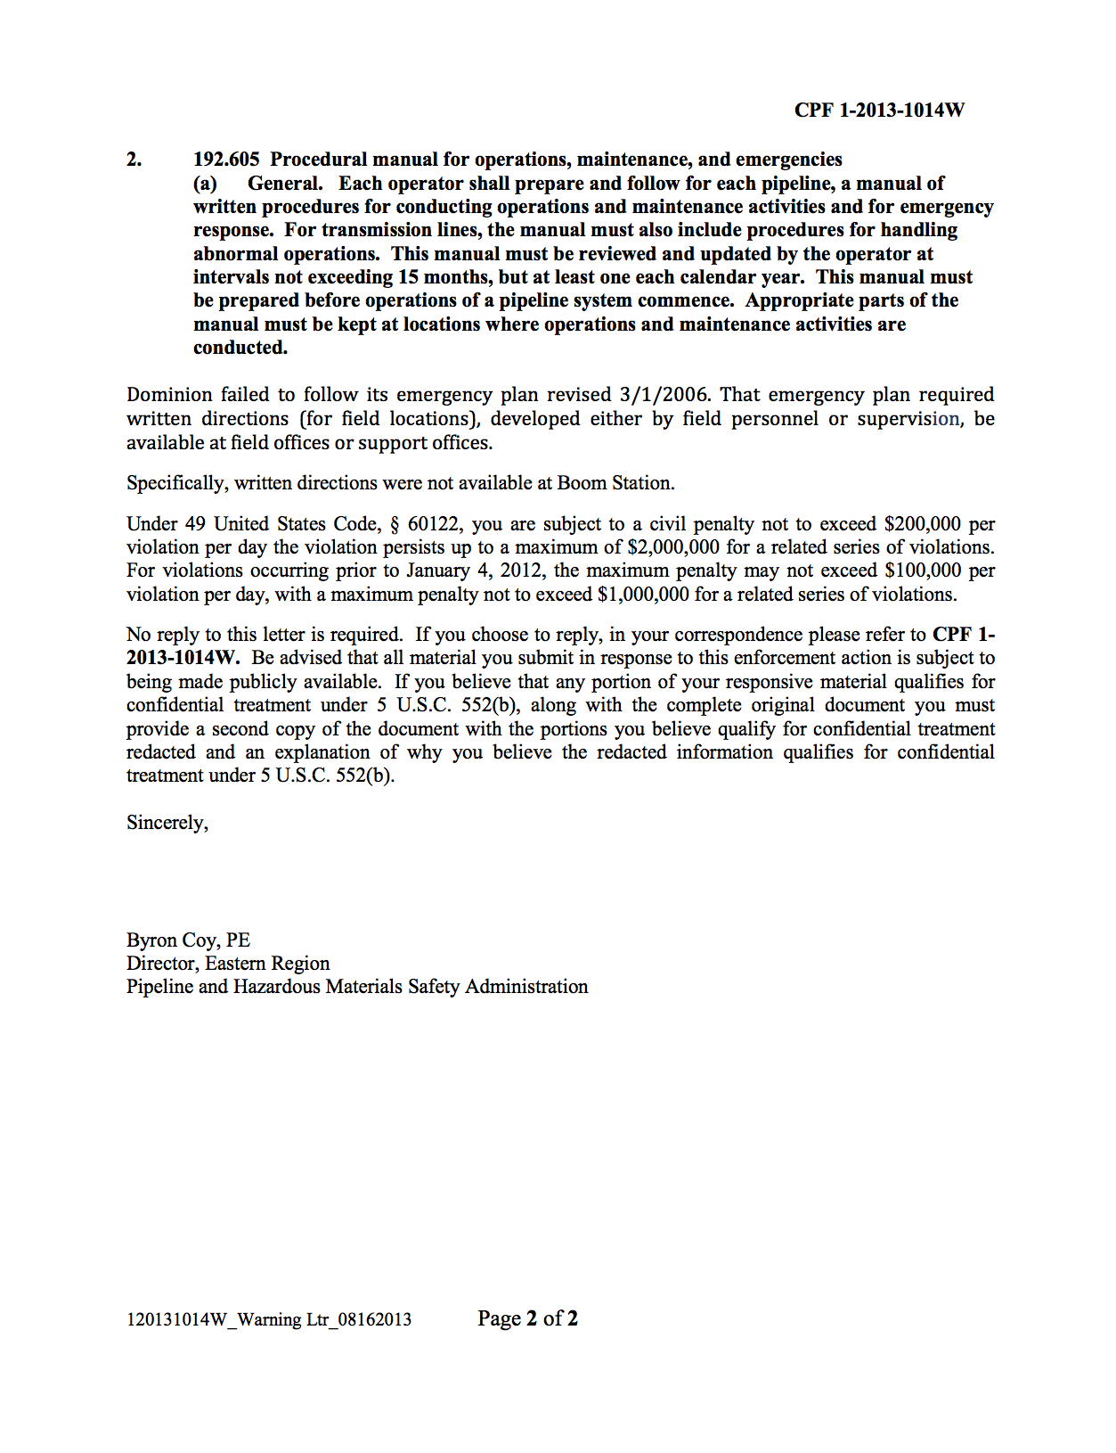

EPA and Dominion Cove Point Settle Violations at Natural Gas Distribution Facility in Maryland

Release Date: 03/17/2015
PHILADELPHIA (March 16, 2015) – Dominion Cove Point, LNG will pay a $365,000 civil penalty to settle alleged violations of federal environmental regulations involving unreported releases of ammonia into the air from its liquefied natural gas distribution facility at 2100 Cove Point Road, Lusby, Md. EPA cited Dominion for failing to report 27 separate releases of more than 100 pounds of ammonia from its natural gas turbines while generating the site’s electricity.
Federal regulations require facilities to report any anhydrous ammonia release above 100 pounds to the National Response Center, the state emergency response commission, and local emergency planning officials. Dominion failed to immediately notify any of these agencies following each of the 27 ammonia releases. It also failed to submit required follow-up reports to the agencies. These reports provide useful information in case an emergency response is necessary.
“When manufacturing facilities experience the release of a reportable substance, they must notify emergency responders so nearby communities can be properly protected,” said Shawn M. Garvin, EPA Mid-Atlantic Regional Administrator. “Dominion Cove is now providing continuous emissions reporting, which benefits the responders and the community.”
The alleged violations come under two federal statues: the Emergency Planning and Community Right-to-Know Act (EPCRA); and the Comprehensive Environmental Response, Compensation, and Liability Act (CERCLA), also known as Superfund. EPCRA requires notification of the state and local authorities, and CERCLA requires notification of the National Response Center.
During the production of electricity to run the facility, the natural gas turbines are equipped with a catalytic system that uses ammonia to control emissions of nitrogen oxides (NOx) from its stacks. Controlling
NOx emissions helps maintain air quality standards and reduces harmful
greenhouse gas emissions.
March 23, 2017- http://www.bayjournal.com/article/court_rules_that_dominions_coal_ash_polluted_elizabeth_river
A federal judge ruled Thursday that Dominion Virginia Power’s storage of coal ash at a now-closed plant near the Elizabeth River has been illegally polluting groundwater and the river for years. The decision could impact Dominion’s plans to permanently store ash in pits at other plants where coal has historically been burned for power.
U.S. District Judge John Gibney Jr. in Richmond ruled that the Sierra Club had proved that arsenic from four coal ash impoundments at Chesapeake Energy Center has contaminated groundwater and seeped into the Elizabeth River. In a 21-page opinion, Gibney wrote that the pollution violates the federal Clean Water Act because the company did not have a discharge permit from state regulators for such releases.
Dominion’s record of repeated environmental and regulatory violations does not create assurance in their competence to construct, operate, and maintain a natural gas pipeline that is larger than they have ever built. The company has repeatedly illustrated a total lack of respect for the environment, and the residents affected. The financial penalties that have been brought against Dominion simply are passed on as expenses to the consumer. In the end, the environment and the consumer are being penalized while Dominion executives and shareholders continue to reap massive profits.

