The photos below show post-harvest conditions of so-called “restoration” projects in R-6, R-1, and R-4. Clearly, the natural resource specialists on the NEPA IDTs paid by the American public to preserve and protect the national forests turned belly-up to please their line-officer with volume. The USFS replaced “timber sale” with “restoration project” to placate the vast majority of the American public who don’t want their national forests logged anywhere for any reason.

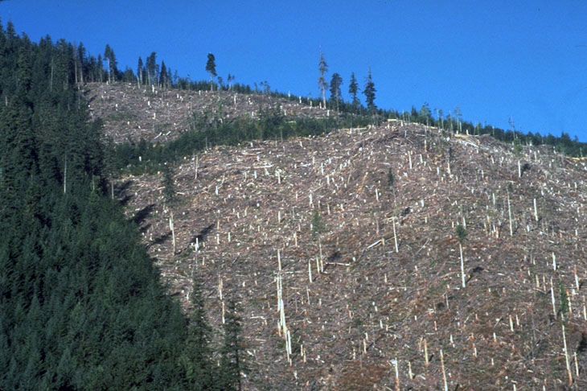
Rogue River NF --- Bulldog Restoration Project

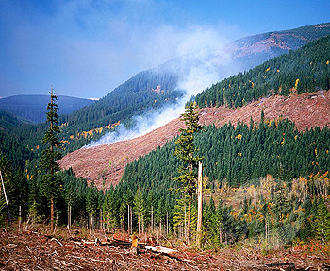
Mt. Hood NF --- Clear Creek Restoration Project

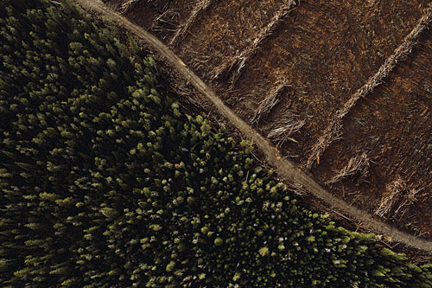

Salmon NF --- Crane Mountain Restoration Project

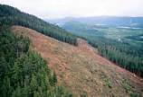
Olympic NF --- Sedgelaw Restoration Project

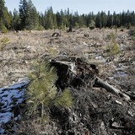
Helena NF --- Bald Bear Restoration Project

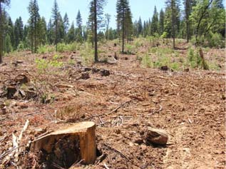
Gallatin National Forest – Heckler Restoration Project

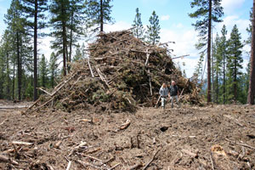

Deschutes National Forest Lava Cast Restoration Project

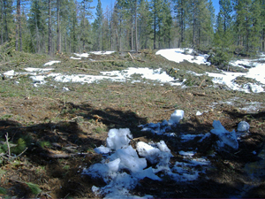
Deschutes National Forest Lava Cast Restoration Project

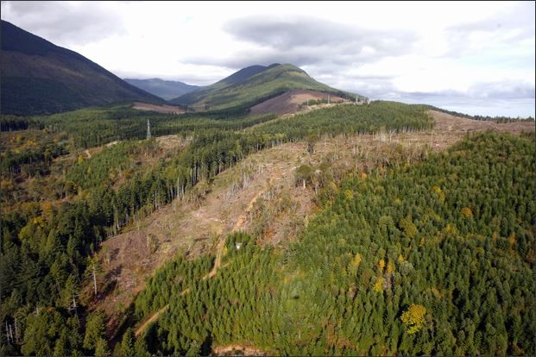

Six Rivers NF --- Upton Heights Restoration Project

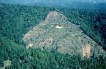

Mount Baker-Snoqualmie NF --- Crenshaw Restoration Project (note the landslide)

