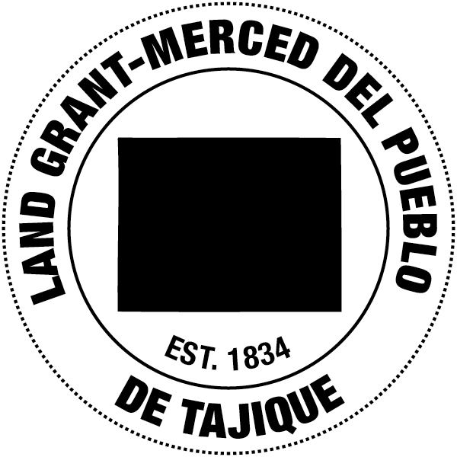
Board of Trustee
Venessa Chavez
President
Felix Barela
Vice President
Adam Baca
Secretary
Andrew Gutierrez
Treasurer
Jerry Montoya
Mayordomo

August 31, 2016

Cibola National Forest

Comments regarding Cibola National Forest Mountain Ranger Districts Plan Revision

We greatly appreciate and acknowledge how far the Forest Service has come in listening and fostering relationships with Land Grant representatives and individual boards. On behalf of the Tajique Land Grant we would like to express our support of Alternative B found in the Cibola National Forest Mountain Ranger Districts Plan Revision Preliminary Draft Land and Resource Management Plan.
This plan seems to be the most suitable alternative for NM Land Grants within the Cibola National Forest. We respectfully request that Alternative B be amended to allow for communal grazing for all land grants not just the Gross Kelley Allotment. We also ask that the Tajique Land Grant Creek not be classified as an eligible Wild and Scenic River.

Our Local Land Grants have always grazed our animals in the forest and we would like you to honor this historical traditional use of our local mountains when such opportunities become available. Communal grazing for the land grant would afford the local community to graze livestock for local consumption, as well as opportunities for economic development.

The Tajique Land Grant Is concerned about the designation of the creek as eligible as a wild and scenic river because of the potential impact on the local communities ability to access traditional use resources within the proposed eligibility corridor.
The Cibola National Forest Mountain Districts plan revision; wild and scenic river eligibility process document dated July 18, 2016 on page 14 under the narrative description of values for the Tajique Canyon acknowledges Land grants traditional use grazing and firewood gathering by the land grant communities have been prevalent in the past and continues to occur throughout the area. While the land grant acknowledges the importance of protecting the creek and its resources we are concerned that the designation of being eligible as a wild and scenic river with a recreational classification may limit our communities’ ability to continue these

afore mentioned traditional uses as well as the forest service’s ability to manage the area for watershed health and protection from catastrophic wildfire.

The community of Tajique is reliant on the health of the creek for quality and quantity of local surface and subsurface water for acequia irrigation and drinking water.

Lastly protecting meaningful access to traditional resources within the proposed area will help ensure cultural integrity for our centuries old historic community.

Respectfully Submitted,

Venessa Chavez

Venessa Chavez
President
La Merced Del Pueblo De Tajique
505-400-0940

