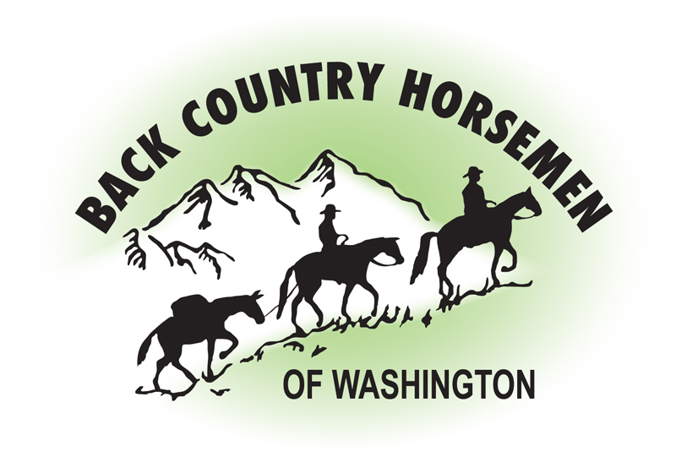
BACK COUNTRY HORSEMEN OF WASHINGTON
PO BOX 1132
ELLENSBURG, WA 98926
WWW.BCHW.ORG

June 28, 2016

Back Country Horsemen of Washington support Alternative Plan P. in the Proposed Revised Land Management Plan for Colville National Forest

In our opinion Alternative P provides the best overall balanced approach to managing the Colville National Forest. It provides high potential to improve wildlife habitat condition, while also managing timber at an optimum production level. The creation of the Kettle Crest SIA allows for mixed use recreation within the forest. The increase in the percentage of the forest that would be managed as non-motorized would increase by 9%, indicating a desire to maintain the characteristics of the backcountry experience of natural solitude.

The percentage of increase of Wilderness area that is proposed in Alternative P is strongly supported by BCHW. We truly love wilderness, but realize that existing wilderness lands are becoming increasingly difficult to access. In our opinion the management of the recommended wilderness should continue to allow non-conforming wilderness uses including motorized trail maintenance and reconstruction until such time as Congress takes action to designate the area(s) as Wilderness. Additionally, with the continuing long term trend of steadily increasing backlog of trails that are becoming impassable due to windfall, BCHW recommends more “Minimum Requirements Analysis” be done on all trail maintenance projects, including those in wilderness. The trail closures due to lack of maintenance are becoming untenable and there are trails that will potentially be lost forever if all the tools and possible solutions are not brought into play in some specific and limited situations. These public lands must be made accessible to the owners of these lands, the American people, who pay for them.

Back Country Horsemen of Washington is an organization consisting primarily of stock users with a mission to keep trails open. The members of BCHW are dedicated to hands on, ground level volunteer projects that will keep our public lands open for stock use and for other recreational user groups. Our members are deeply invested in the wild places of our beautiful state and want to make certain that these places are not lost, or forgotten. In 2015 Back Country Horsemen contributed over 70,000 volunteer hours on public lands, with a significant percentage of that work occurring in the National Forests and Wilderness.

Thank you for the opportunity to provide comments on this important plan.

s/Kathy Young
Kathy Young
President, Back Country Horsemen of Washington
president@bchw.org

