Carol Niehoff
P.O. Box 731
Mount Lemmon, AZ 85619

August 26, 2013

Dear Congressman Barber and Ms. Werden:

We greatly appreciate your interest in the fire vulnerability of Summerhaven/Mt. Lemmon. While we are a small community, we host a reported 1.5 million visitors annually. After the devastation resulting from the Aspen Fire that originated in the forest near Marshall Gulch, community concern shifted to the un-thinned, Upper Sabino Watershed that did not burn.

We are well aware of Wildlife Habitat challenges in addressing this area and, more specifically, the Spotted Owl nesting area. As they did with the Greater Summerhaven area, the US Forest Service has assured us that the Upper Sabino Watershed, west of Turkey Run is not vulnerable since there exists sufficient water and adequate access. However, with the extended drought, the USFS area abutting homes on Turkey Run is not unlike Carter Canyon prior to its immolation in the Aspen Fire. As a community, we depend on the Sabino Watershed and Tucson enjoys the extraordinary recreational gift of Sabino Canyon. While smaller in scope, we mirror the concerns and needs demonstrated in Santa Fe, New Mexico that benefited from $7 million in Federal Funding to protect their watershed. See: http://www.santafenm.gov/index.aspx?NID=2442
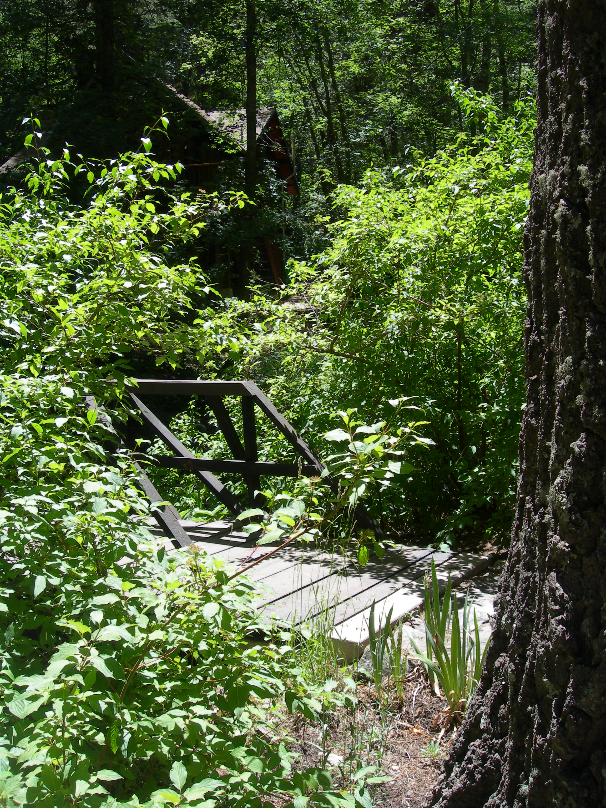

“In 2002, soon after the devastating Cerro Grande Fire in Los Alamos County, the City of Santa Fe and the U.S. Forest Service needed to secure our water source from the threat of fire. Thus began the 10-year forest treatment program to reduce the fuel load within the non-wilderness portion of the Municipal Watershed. With broad support from the community and local and national environmental groups like the Santa Fe Watershed Association and The Nature Conservancy, the U.S. Forest Service has successfully reduced the fuel loads on over 5,500 acres of ponderosa pine dominated forest within the non-wilderness portion of the Municipal Watershed. Thinning treatments have consisted of 1) cutting smaller diameter trees (<16" dia.) to restore tree density to natural fire regime levels (reduced from >1,000 trees per acre to 20-50 trees per acre), 2) slash pile burning, and 3) broadcast burning. Funding for this work came primarily from a $7 million congressional earmark, and a $1 million grant received in 2009 from the New Mexico Finance Authority Water Trust Board, both of which have now expired.”

We look to your influence as our Congressional Representative and Staff to support the forest "thinning" as presented by Senators McCain and Flake. Also, we understand that there is a possibility of work to be done in the Sabino Watershed as a Demonstration Project. A letter to our local District Forest Ranger, Stan Helin in support of this project would help to move it forward.

Sincerely,

Carol Niehoff
(520) 576-1538

