Nancy Lord 907-235-8252 (h)
P. O. Box 558 907-299-1274 (c)
Homer, Alaska 99603 nlord@xyz.net

February 3, 2016

U. S. Forest Service
Chugach Plan Revisions

To whom it concerns:

I am a recreational user of Chugach Forest lands and the waters of Prince William Sound, as well as a former commercial fisherman who has tendered salmon in the Sound. I’m also a science writer very familiar with climate change issues. I wish to comment on the new plan.

The plan you have currently proposed is inadequate for protecting existing values. In fact, it undermines existing protections when what is needed is more active stewardship of an area that is receiving increasing use and currently supports tremendous fishery, recreational, tourism, scientific, and ecosystem values.

I strongly and sincerely request that the plan recommend to Congress that the entire Wilderness Study Area—the original two million acres—be designated as Wilderness. Until and unless it is, the WSA should be actively managed as Wilderness.

The Copper River and Bering River should be strongly protected in their natural states. The Copper is a major source of salmon for commercial, subsistence, and personal use and should not be compromised by competing uses, or degraded in any way.

Prince William Sound has never recovered from the Exxon Valdez Oil Spill, and the EVOS Restoration mandate should be upheld.

All Chugach National Forest lands should be permanently withdrawn from mineral leasing and large-scale forestry. These uses are not compatible with the values of fish and wildlife and recreation and tourism.

Climate change is stressing us everywhere, which calls for strategies to protect valuable ecosystems and allow for resilience. The Chugach Forest is certainly one of those areas best reserved for ecosystem values and scientific studies. Please take to heart your own climate change assessment. Moreover, the increased visitation the Chugach is already receiving has put enough demand on it and needs to be managed to maintain existing values; increased use, especially by extractive industries, will only further degrade the region and limit future opportunities.

Thank you for the opportunity to comment.
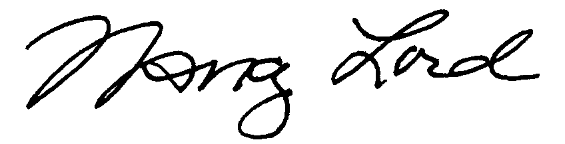
Nancy Lord

