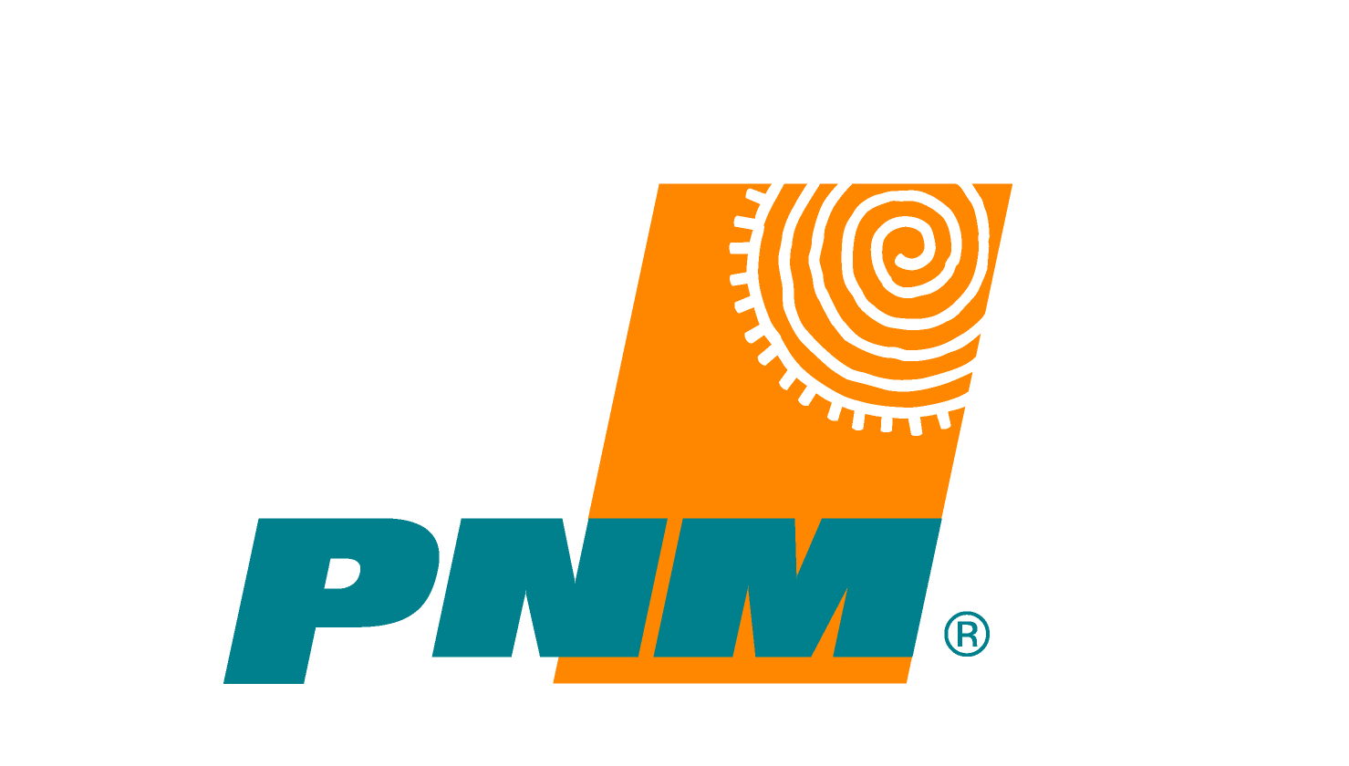
PNM
Environmental Services
2401 Aztec NE Z100
Albuquerque, NM 87107

P 505.241.2162

F 505.241.2384
www.pnm.com

September 25, 2015

Forest Planner
Cibola National Forest and National Grasslands
2113 Osuna Rd. NE
Albuquerque, NM 87113

RE: Cibola National Forest Resource Management Plan Revision, Phase II Wilderness Area Comments

Dear Mr. Green,

Attached are comment forms and maps detailing PNM’s comments on several proposed Wilderness parcels in the Cibola National Forest. Our comments are a result of a cursory analysis of potential impacts to our operations and maintenance under our Special Use Permit from the potential inclusion of new Wilderness Areas (Phase II) defined during the RMP review process.

Working immediately adjacent to wilderness presents significant challenges with placement of multiple cranes and bucket trucks, vegetation management, fire control and overland access. The potential that the boundary would not be fenced further complicates the ability to recognize and avoid such exclusion areas. In several instances a minor offset in the boundary of a proposed Wilderness area would result in decreased impacts to our continuing operations on the Forest. Such an offset would also further other forest management objectives such as fuel reduction and Wildland Urban Interface management.

However, in some areas it appears the location of PNM facilities were not recognized. A reassessment of those areas is needed to comply with the Forest Service's wilderness evaluation process. PNM is interested in working with the Plan Revision Core Team to provide additional comments should the Parcels that are commented upon in this package be moved forward.

We appreciate the opportunity to comment on the Cibola National Forest Resource Management Plan revisions. Please contact PNM if you have any questions or concerns related to our comments.

Sincerely,

David Reynolds

