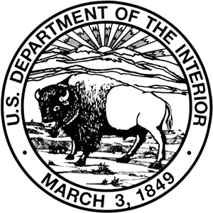 United States Department of the Interior
Office of the Secretary
Office of Environmental Policy and Compliance
Pacific Southwest Region
333 Bush Street, Suite 515
San Francisco, CA 94104

IN REPLY REFER TO:
(ER 14/0778)

Filed Electronically

26 January 2014

Carson Ranger District
Humboldt-Toiyabe National Forest
1536 South Carson Street
Carson City, NV 89701

Subject: Draft Environmental Impact Statement (DEIS) US Forest Service (USFS),
Bordertown (NV) to California 120kV Transmission Line, Humboldt-Toiyabe
National Forest, Carson Ranger District, NV
Dear Gentlepeople,

The Department of the Interior has received and reviewed the subject document and has no comments to offer.

Thank you for the opportunity to review this project.

Sincerely,
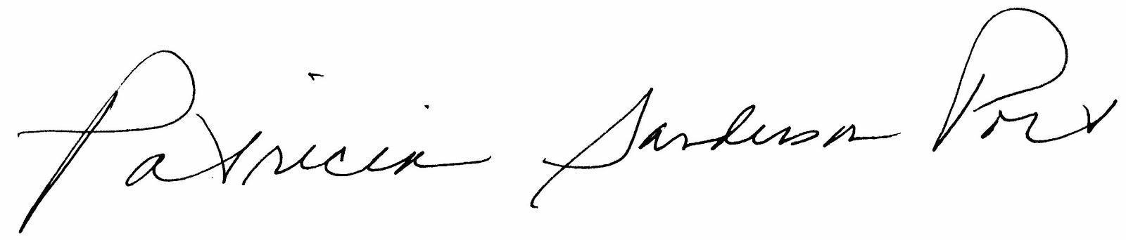
Patricia Sanderson Port
Regional Environmental Officer

cc: OEPC-Staff Contact: Shawn Alam, 202-208-5465; shawn_alam@ios.doi.gov

