RECEIVED JAN 2 2 203 HTNF - S.O.
January 17, 2015
Bordertown to California 120 kv transmission line project comments:

The residents of Long Valley are concerned about the expansion of the Bordertown substation and the impact it will have on our area. During the 1990s, we participated in the Alturas Transmission project and worked with the California Department of Historic Preservation to develop a mitigation plan. I have attached the document signed by Sierra Pacific employee John Owens which agrees to implement and uphold the landscaping at the Bordertown substation site.

With the proposed expansion now, we are asking for expanded landscaping to mitigate any further visual impacts to Sierra County road 570 and Long Valley. We are proposing the following:

- Extend the north side of existing berm approximately 500-700 feet. In the first paragraph of the attached Agreement, 20 cottonwood trees were planted in the ravine north of the substation. These trees were not irrigated and died, leaving the substation exposed.
- Plant 30 IRRIGATED evergreen # 1 quality, 15 gallon trees on the newly extended berm.
- We would like to amend the current agreement to include a 5 year guarantee for the newly planted trees; after the 5 year period, if 15% of the trees die from either manmade or natural circumstances, Nv Energy will replace them with original # 1 quality stock
- Use a dull anti-glare finish on all tower structures.

During the Alturas Tranmission line "discussions", Sierra Pacific assured residents that there were no further plans to expand the Bordertown substation, that is would remain it's current size. Now, less than 20 years later, that is not the case. It is therefore EXTREMELY important that the mitigation measures agreed upon with the California Department of Historic Preservation and the California CPUC are upheld for this expansion as well as any other future development of the Bordertown substation.

Sincerely, ( .

' an J1 venn

d i Ranch
/IV.ffe l/VLJ

Citizens for the Preservation of Long Valley

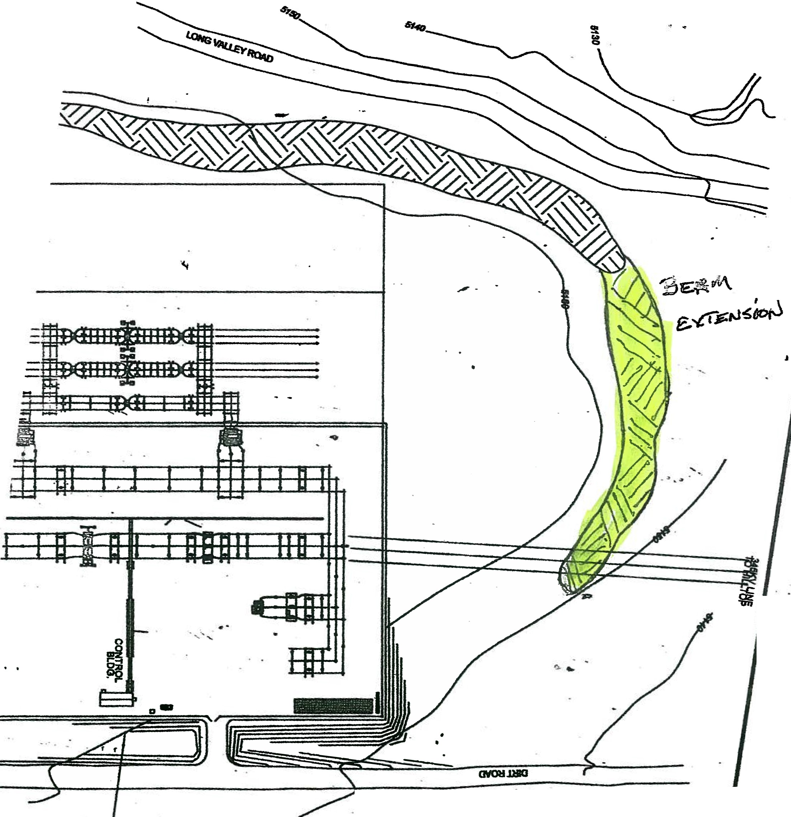! <

...

.. ---... ·- .· .._ _ - .._ -

. .
!="i ur-e A '! _ .
&rd.a rf11u}v., S:ub l-rlYJ
Dretbf- E i S
i !
&r&idow'l i:;, la.lf-0 _
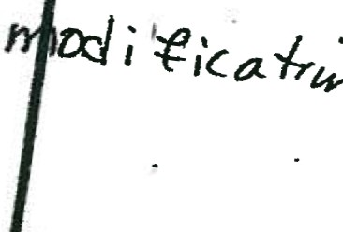1 o K..u -bl""""iRY> I vimicf..

AGREEMENT

In order to maintain the historic integrity of Long Valley and the old 1862 ranch, Sierra Pacific Power Company (Sierra) agrees to revise the Bordertown Substation landscaping plan per discussions held 3-4-98 and 3-6-98, between Sierra and the Loverins. The revised landscaping plan was provided to the Loverins on 3-9-98, for final review and approval. The plan includes the installation of not less than 90 native evergreen trees in the size, location, and quantity called for on the revised landscaping plan with a well and irrigation system to water the trees called for in the landscaping plan.. In addition, Sierra shall install, no less than 20 - 3 to 6 foot tall Cottonwoods/Aspens in the ravine North of the Bordertown Substation per the revised landscaping plan.

Sierra further agrees to file a variance request with the California Public Utilities Commission (CPUC) and the Bureau of Land Management (BLM) to amend the Construction, Operation, and Mainteance Plan for the Alturas Intertie Project to make the revised landscaping plan an official part of the Project requirements. CPUC, BLM and Sierra County shall have enforcement authority with respect to the long term maintenance of the landscaping described above. Sierra agrees to replace any trees which die within a 5 year establishment period with a tree of the same size and species of the original planting. After the 5 year guartee period, if 15% of the trees die from either natural or manmade circumstances (e.g., disease, fire, flood, etc.), Sierra Pacific will replace them in the original size with #1 stock.

On the property owned by Sierra, adjacent to the Loverin Ranch, Sierra shall plant 20 - 8 to 10 foot tall evergreen trees. The location of these trees shall be determined by the Loverins (after the Bordertown Substation and Alturas Power line from this substation to the Nevada state line is completed). Sierra shall also install a PVC pipe from the sming on Sierra's property to the drainage ditch north of the existing road on Sierra's property adjacent to the Loverin Ranch.

Sierra shall complete construction of all the items listed above no later than 11-1-98. In recognition of this agreement, the Loverins shall Contact the California Office of Historic Preservation representative (Mr. Chuck Whatford) and advise him that an agreement with Sierra has beeri reached which adequately addresses their concerns by 3-16-98.
f

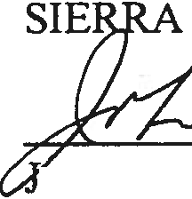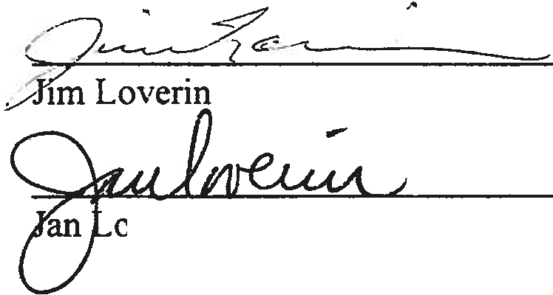PACV
ohn C. Owens, Project Manager
. ,,..

Joseph McDole State Historian II
California Historic Preservation Office 1725 23rd Street
Sacramento, California 95816
January 17, 2015

Dear Mr. McDole

Nevada Energy (formerly known as Sierra Pacific Power Co) is proposing to build a 120 kv transmission line from the Bordertown substation, located in Sierra County to the California substation, also located in Sierra County, California. The draft EIS has been prepared and the lead agency on this project is the USDA Forest Service, Humboldt­ Toiyable National Forest, 1200 Franklin Way, Sparks, Nevada. William A. Dunkelberger is the Forest Supervisor and Marnie Bonesteel is the project manager.

Nevada Energy is proposing to expand the Bordertown substation and we are concerned about the impacts. I have submitted my comments to the Forest Service and have included them for you.

The Bordertown substation, located in Long Valley (adjacent to the Nevada stateline) was initially built as part of the Alturas Transmission project. At that time, Long Valley and our ranch, The Old 1862 Ranch were deemed eligible for inclusion in the National Register of Historic Places. With the support of the California SHPO, we were able to include mitigation measures which included a berm and installation of evergreen trees, which provide visual screening.

Now, Nevada Energy is proposing to expand the Bordertown substation and we again, are looking to the California SHPO for support. We are proposing an expansion of the existing berm approximately 500 feet to the north of the substation. We also would like 30 IRRIGATED # 1 quality 15 gallon evergreen trees to be installed on the berm. This will provide visual screening from Sierra County Road 570 aka Long Valley Road and help maintain the historic integrity of Long Valley and the Old 1862 Ranch.

We would also like to amend the current agreement to include a 5 year guarantee for the newly planted trees; after the 5 year period, if 15% of the trees die from either man.made or natural circumstances, Nv Energy will replace them with original size # 1 quality stock.

Please do NOT CONCUR w the proposed EIS, but INCLUDE these very appropriate mitigation measures in your comments.

Sincerely, _ !l_.,,l {
kverin d l c;anch
Citizens for the Preservation of Long Valley

Cc: Carol Roland-Nawi , SHPO
Marnie Bonsteel, US Forest Service
Tim Beals, Brandon Pangman, Sierra County

