The Wolf Aviation Fund
Promoting and Supporting General Aviation

2060 State Highway 595 Lindrith, New Mexico 87029 www.wolf-aviation.org phone 575-774-0029 fax 815-572-9192

November 14, 2014

Nez Perce-Clearwater National Forests Forest Plan Revision
903 3rd Street
Kamiah, ID 83536

Dear Forest Supervisor Brazell and Coordinator Hennessey,

I have enjoyed outdoor recreation activities since I was a child and have backpacked since 1960, at that time mostly in the High Sierras of California. And one of my motivations for learning to fly in 1975 was to be better able to access my favorite mountain and desert recreational areas via lightplane.

Thus it should be no surprise that I urge you to maintain and enhance light aircraft airstrips and access to the Nez Perce-Clearwater National Forests in this plan revision.

Planning Rule Support: Note that the USFS Planning Rule mandates that recreational use and access, including by means of aircraft and airstrips, be considered and where practicable be maintained and provided for in forest planning efforts nationwide. As a supporter and representative of the Recreational Aviation Foundation I participated in the drafting of the Planning Rule and helped in providing information leading to the inclusion of such language.

As much as any of your other forest visitors, I too value all the scenic, recreational, and revitalizing aspects of visits to our natural lands. And I have come to appreciate the fact that access by air is likely perhaps the most compatible and least disruptive method available.

Unlike access by roads, pack trains, ATV’s, and other means, aircraft do not tear up the terrain or require long stretches of roads in remote areas to provide access. This also enhances the USFS objective of distributing access so usage is less concentrated, and in providing access to more remote areas without the disruption caused by construction of roads.

We who enjoy backcountry aviation call it “The only mode that needs no road.” And in fact most remote airstrips comprise no more than a short, narrow stretch of grassy or natural terrain, with virtually no negative impact on the scenic or natural qualities of an area.

USFS Chief’s 2009 Directive: Please note that in addition to the requirements of the Planning Rule, in a USFS Letter Directive dated July 2, 2009, addressed to all levels of USFS staff, Chief Kimbell wrote, in part:

“Aviation has been part of our country's heritage, both as a mode of transportation and as a means of access to remote and scenic areas for a wide variety of purposes. Backcountry airstrips are an appropriate use of National Forest System (NFS) lands as they provide enhanced access for a variety of legitimate recreational activities and serve recreational pilots. Providing and maintaining backcountry airstrips enhance the spectrum of recreational uses of NFS lands.” This policy has been endorsed and continued by current USFS Chief Tidwell.

Intent of Congress, 2nd Session House Resolution 1473, “Supporting backcountry airstrips and recreational aviation.” In part, says:

“Whereas recreational airstrips have a small footprint on the landscape, provide for dispersed recreational activity, and act as internal trailheads within backcountry areas:
Now, therefore, be Resolved, That the House of Representatives recognizes the value of recreational aviation and backcountry airstrips located on the Nation’s public lands and commends aviators and the various private organizations that maintain these airstrips for public use. “ Passed by unanimous vote September 20, 2011

Your Forest Plan should not only ensure that any airstrips that have ever been in use in the past or are in use now be appropriate candidates for continued use and maintenance. Where possible partnerships should be formed with recreational aviation user groups and state agencies for such periodic maintenance, reducing if not eliminating such costs for the USFS. Development of such partnerships are again a significant part of USFS policy.

And your Forest Plan should also provide that opportunities for enhanced or new airstrips should be entertained in the future, recognizing that such a means of access not only permits pilots and their families access to often underutilized parts of the forests, but also permits visitors with handicaps such as disabled children and wounded warriors the opportunity of easy access to remote areas where they too can enjoy solitude and true backcountry experiences otherwise unavailable to them

And of course remote airstrips also serve to enhance the ability of scientists, managers, and the media to research and document our natural and remote areas, as well; and also serve as important emergency landing spots for aircraft overflying the forests.

In conclusion, please be sure the Forest Plans provide for preserving and enhancing our existing forest airstrips and for entertaining possible new locations for these valuable “aerial trailheads” for future generations.

Regards,
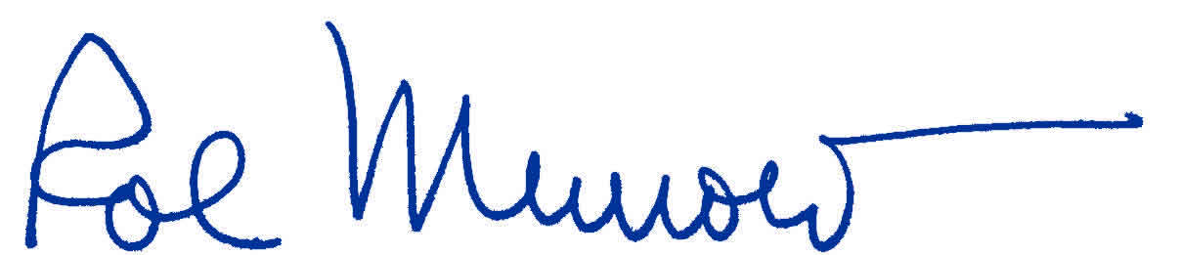

William “Rol” Murrow, Executive Director
The Alfred L. and Constance C. Wolf Aviation Fund

