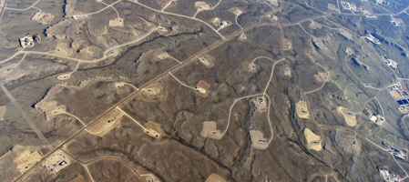
The Pike and San Isabel National Forests could end up like the Johan Gas Field—on public land in Wyoming. It looks just like this near Rifle, too. I don’t want our forests to look like this!

